Quiz Manager – Synoptic Project

Contents

Design 2

Creating the Back-end 3

Creating the Front-end 10

Conclusion 19

# Design

I created the following wireframe designs for the project in Figma.

**Landing page**

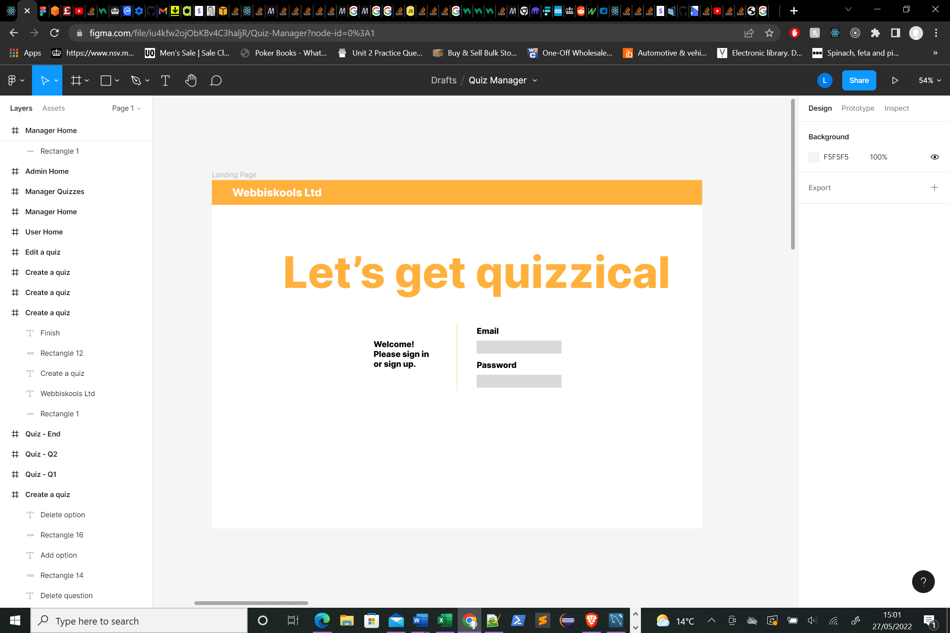

The landing page will allow the user to input login details.

**Quiz Home**

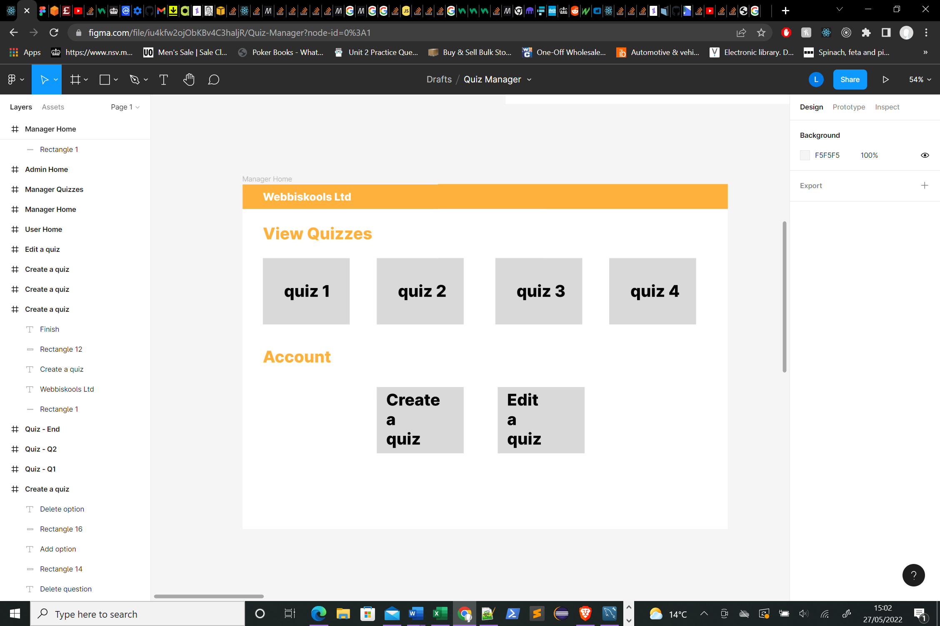

Quiz home will allow a user to select existing quizzes, create a new quiz or edit a quiz.

**Create a Quiz**

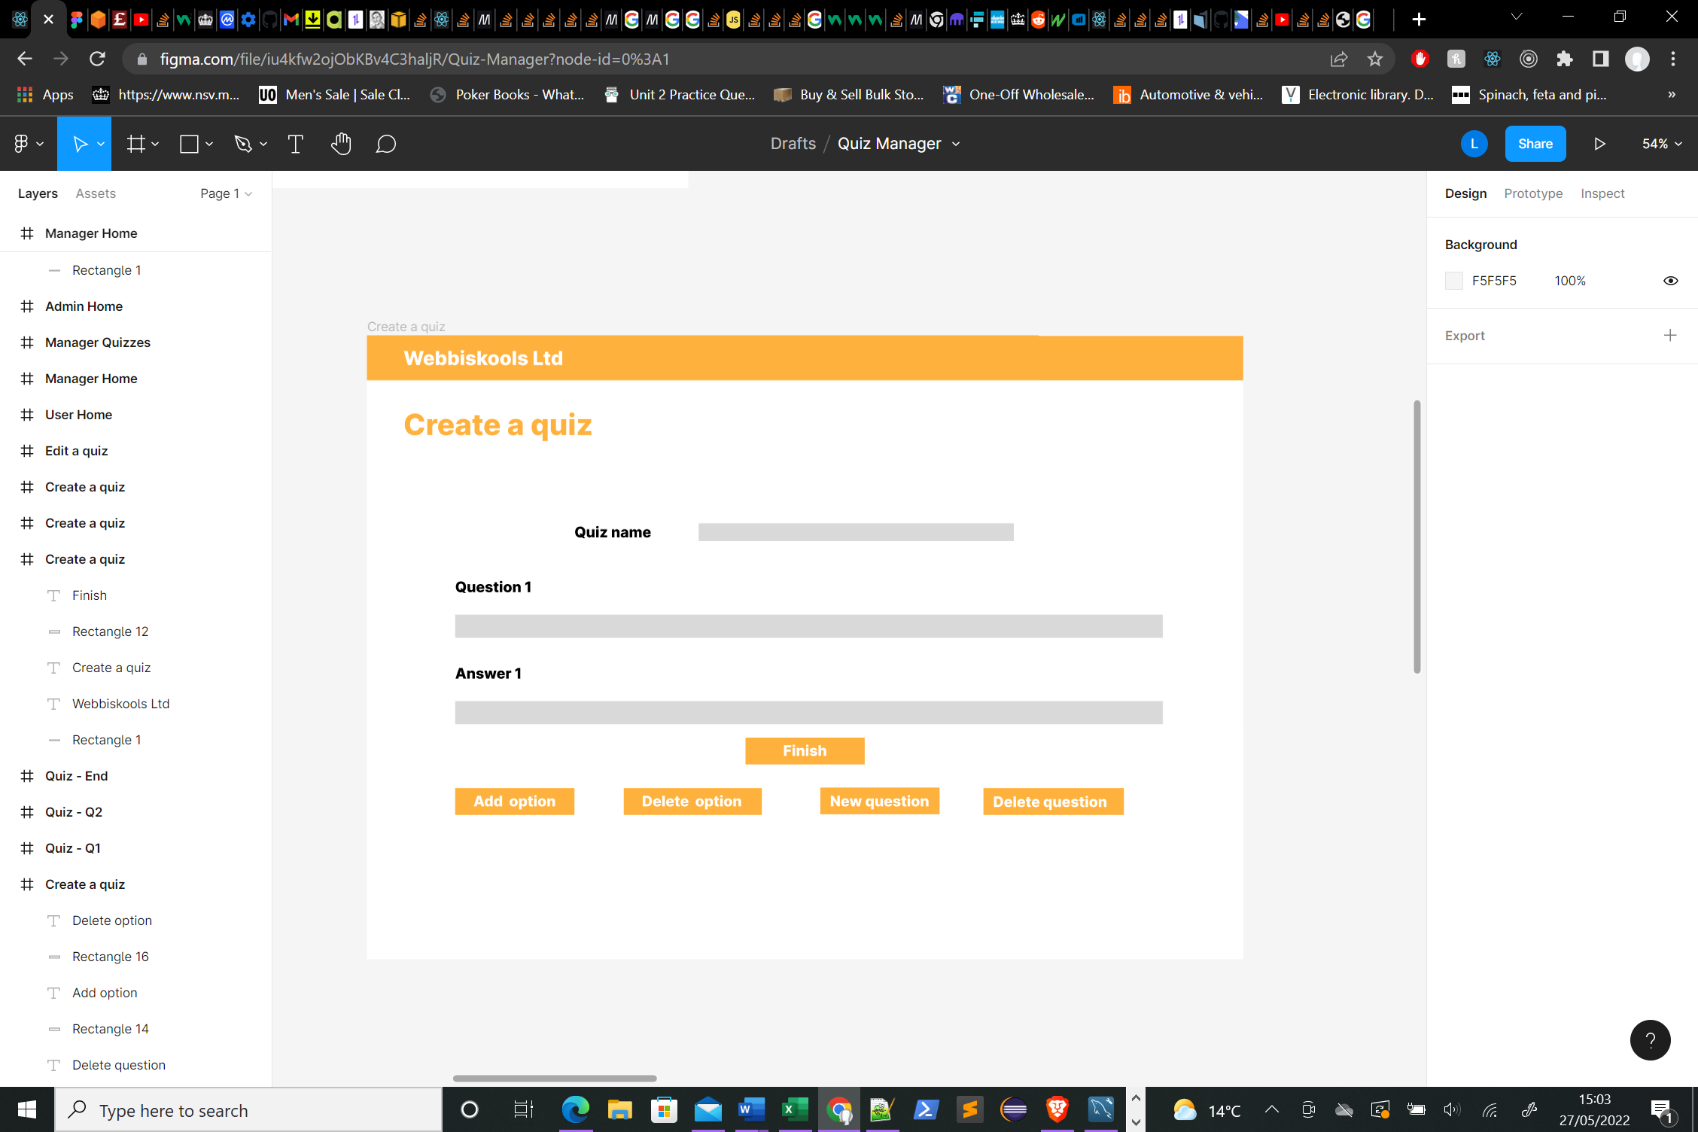

Create a quiz will allow the user to manipulate a form and submit a new quiz to the server.

# Creating the Back-end

I decided that the application would need the following tables: user, role, quiz, question and answer. A data structure of the relationship between these tables is shown below.

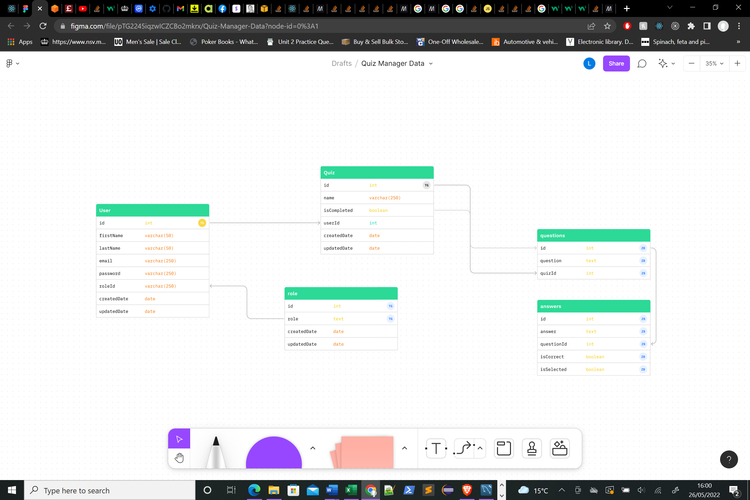

I chose AWS to host my database.

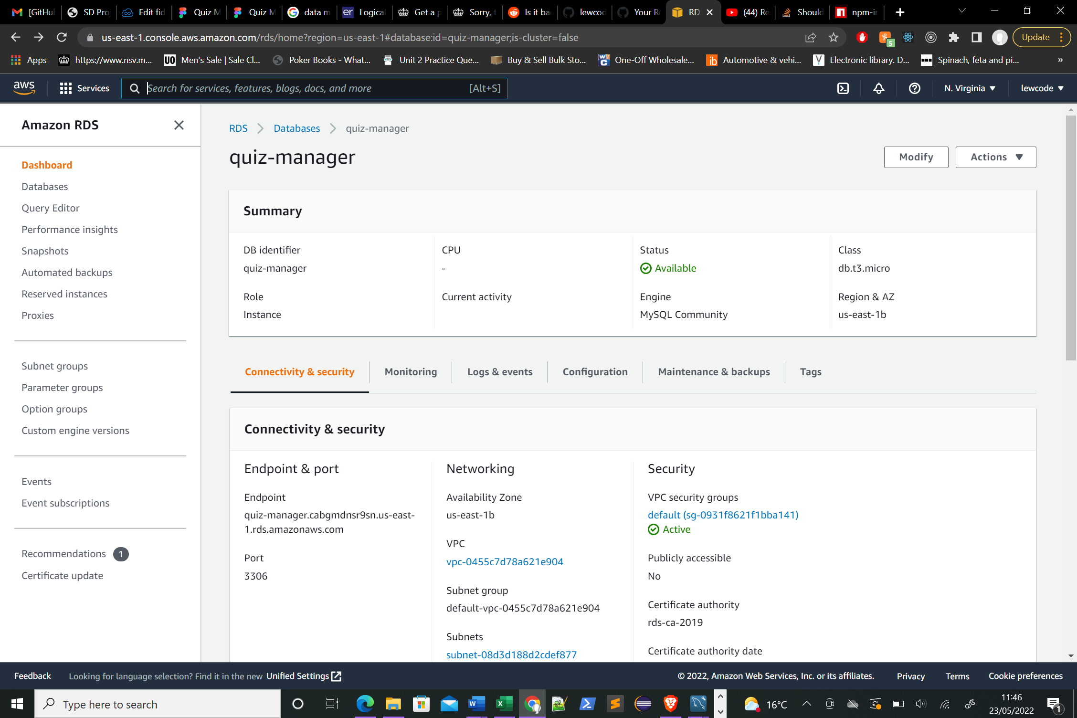

I created the tables in mySQL workbench using the following SQL.

**User Table**

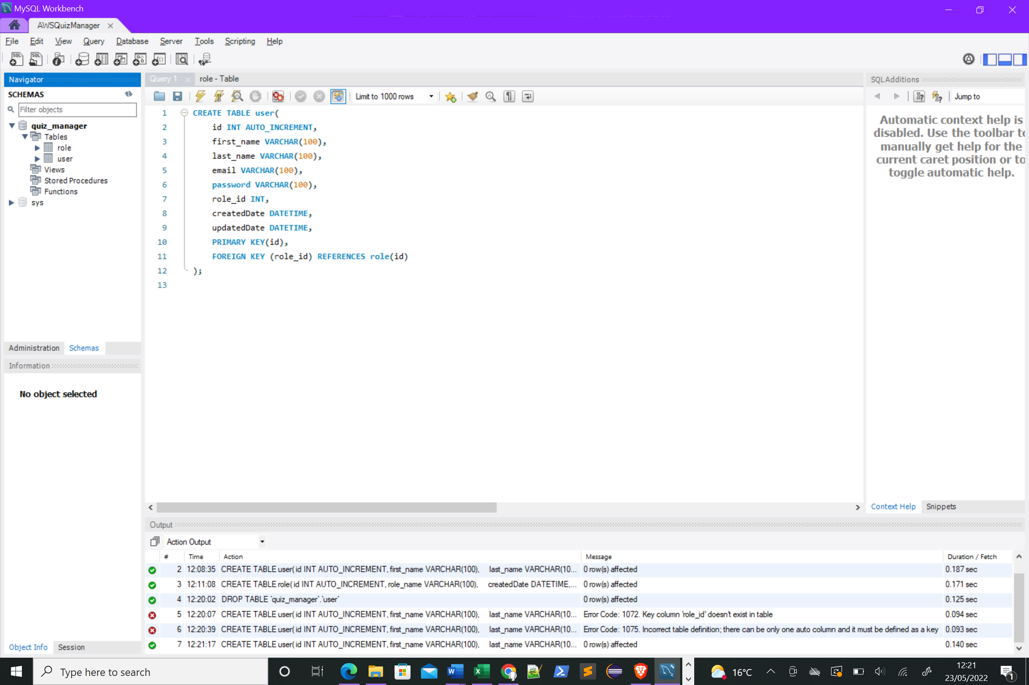

**Role**

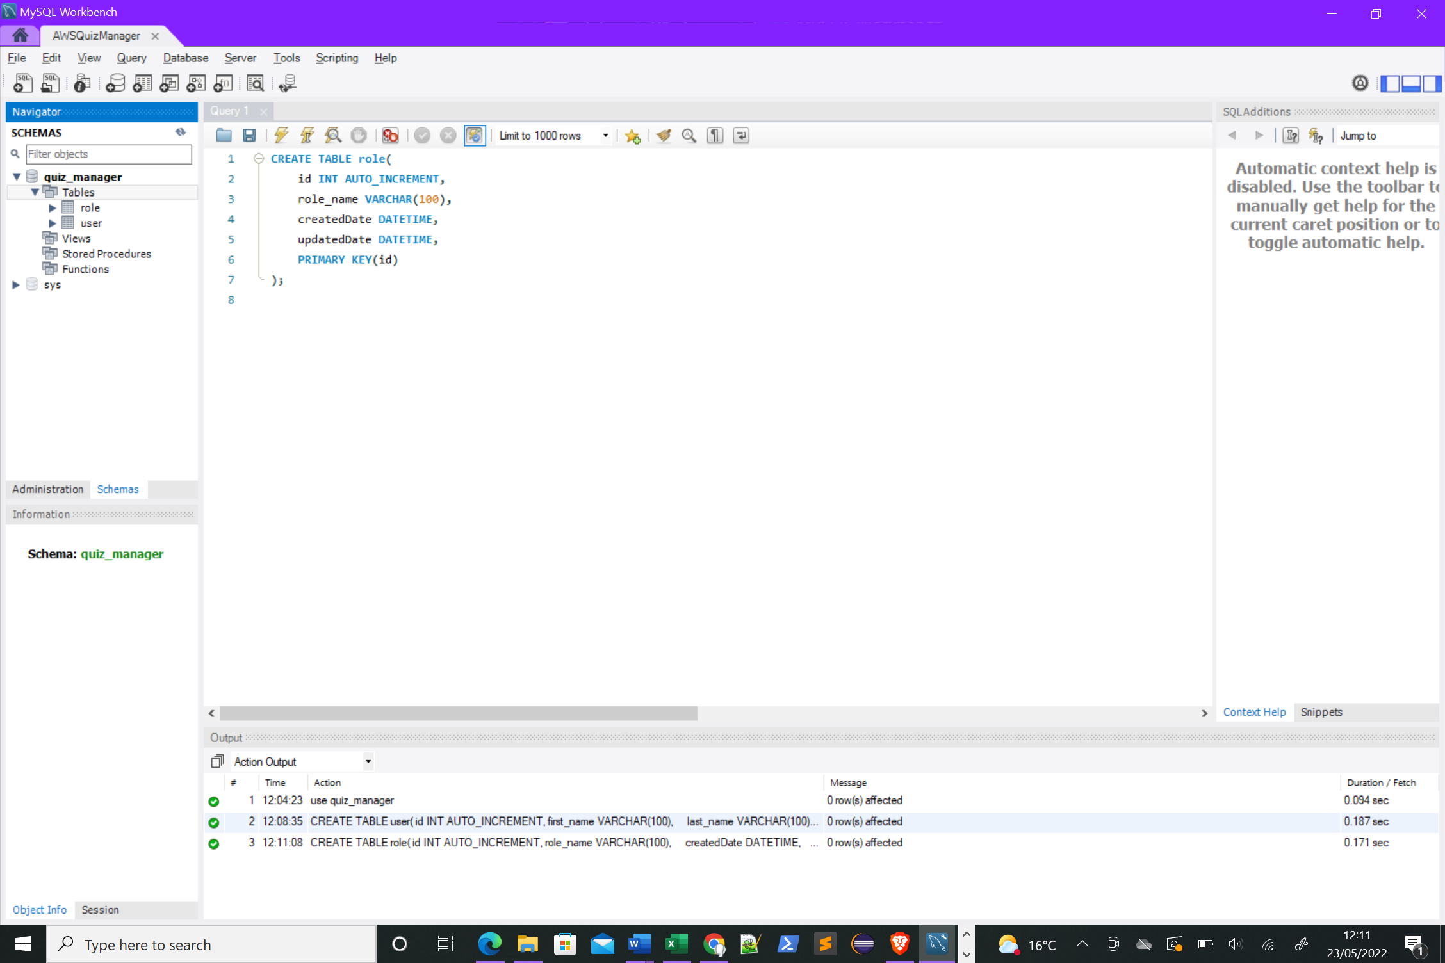

Roles were added manually.

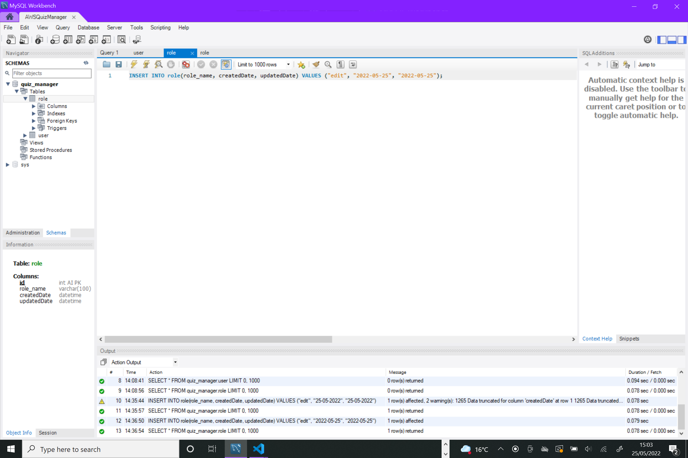

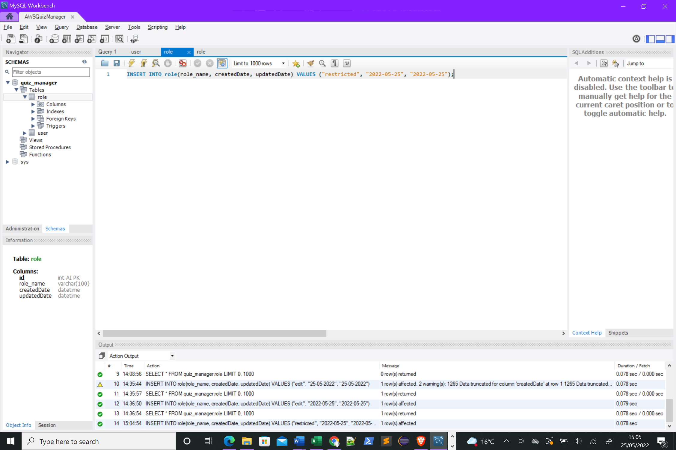

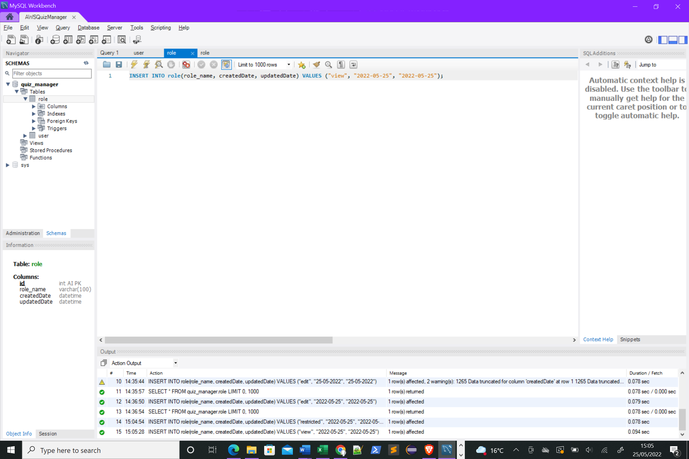

A test user was created.

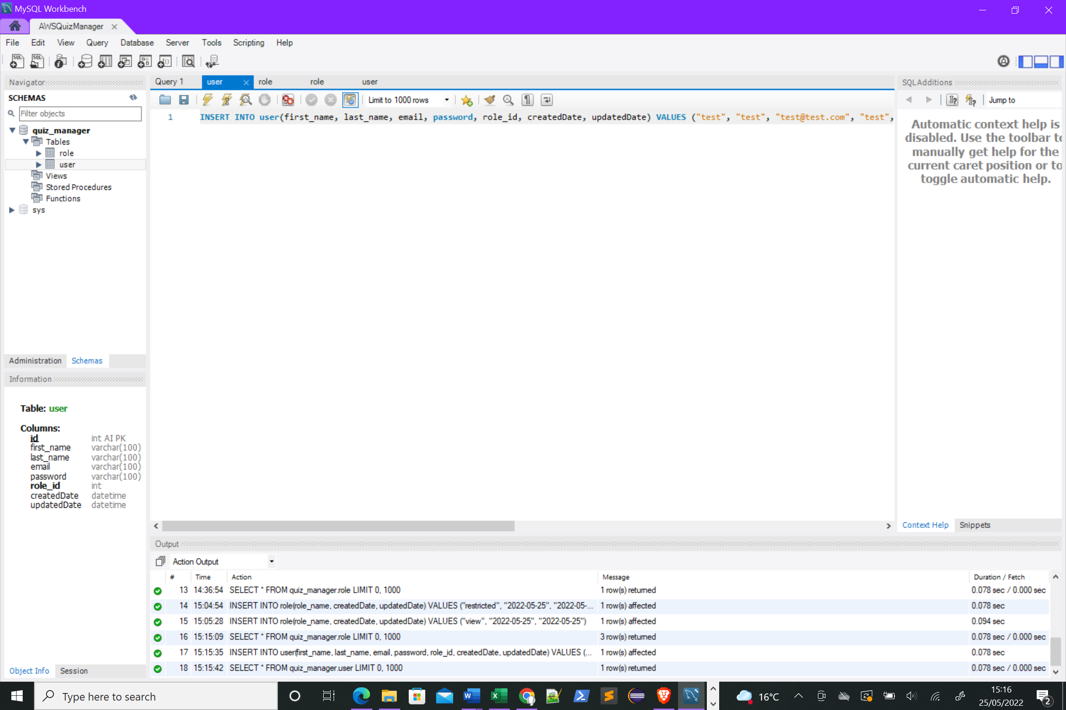

I then created the quiz table.

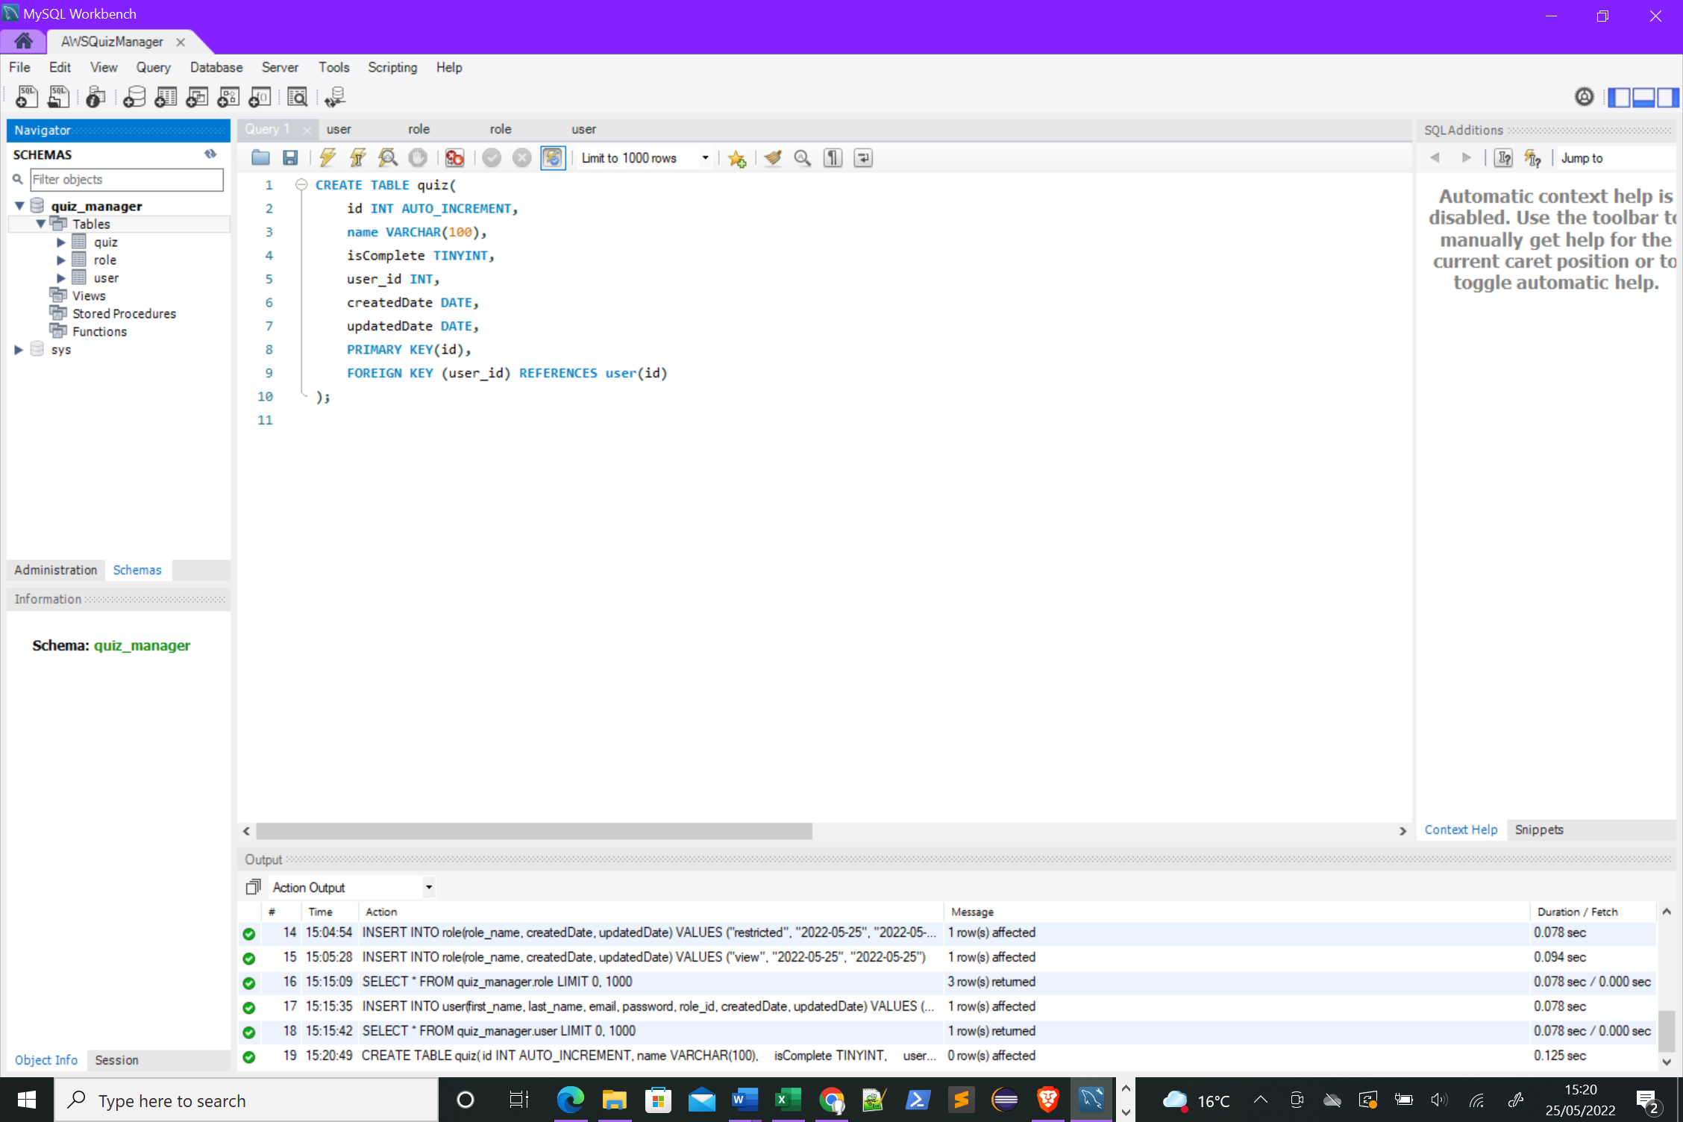

Followed by the answer table.

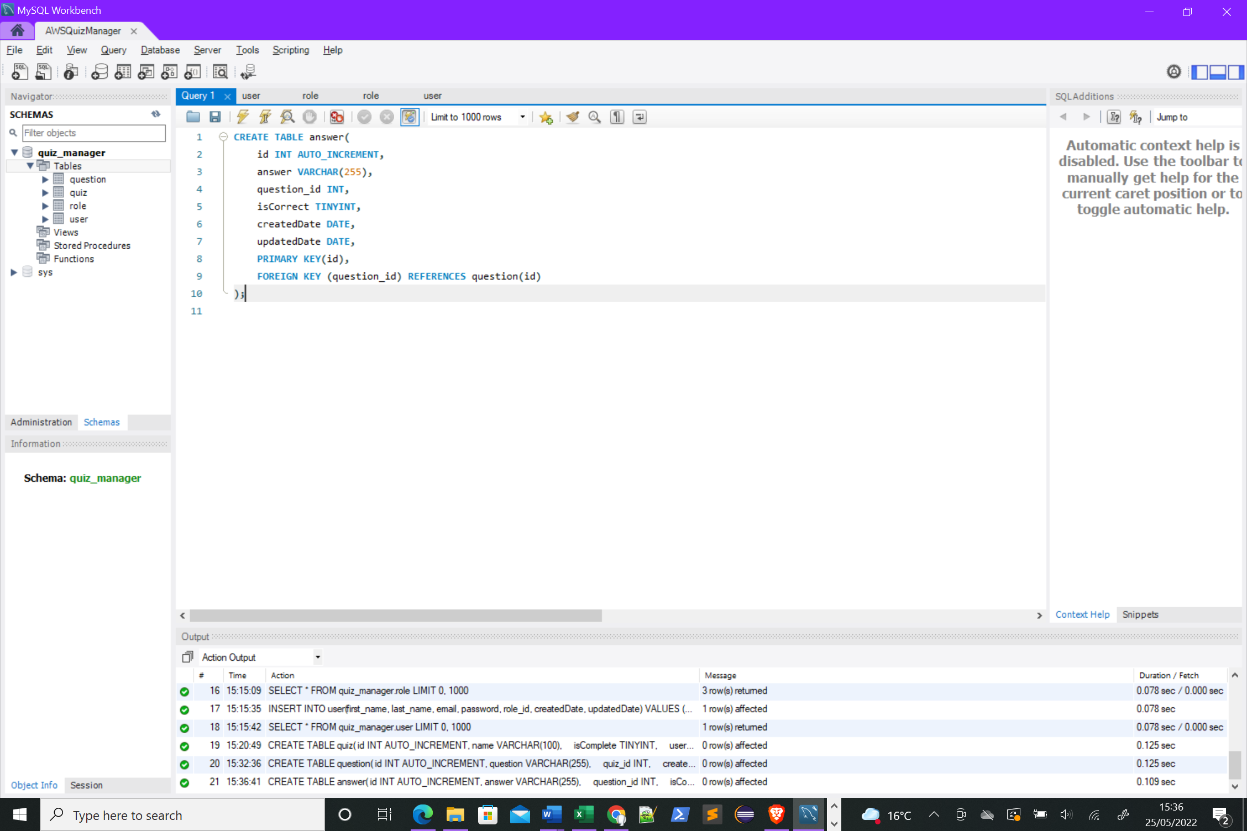

Finally the question table.

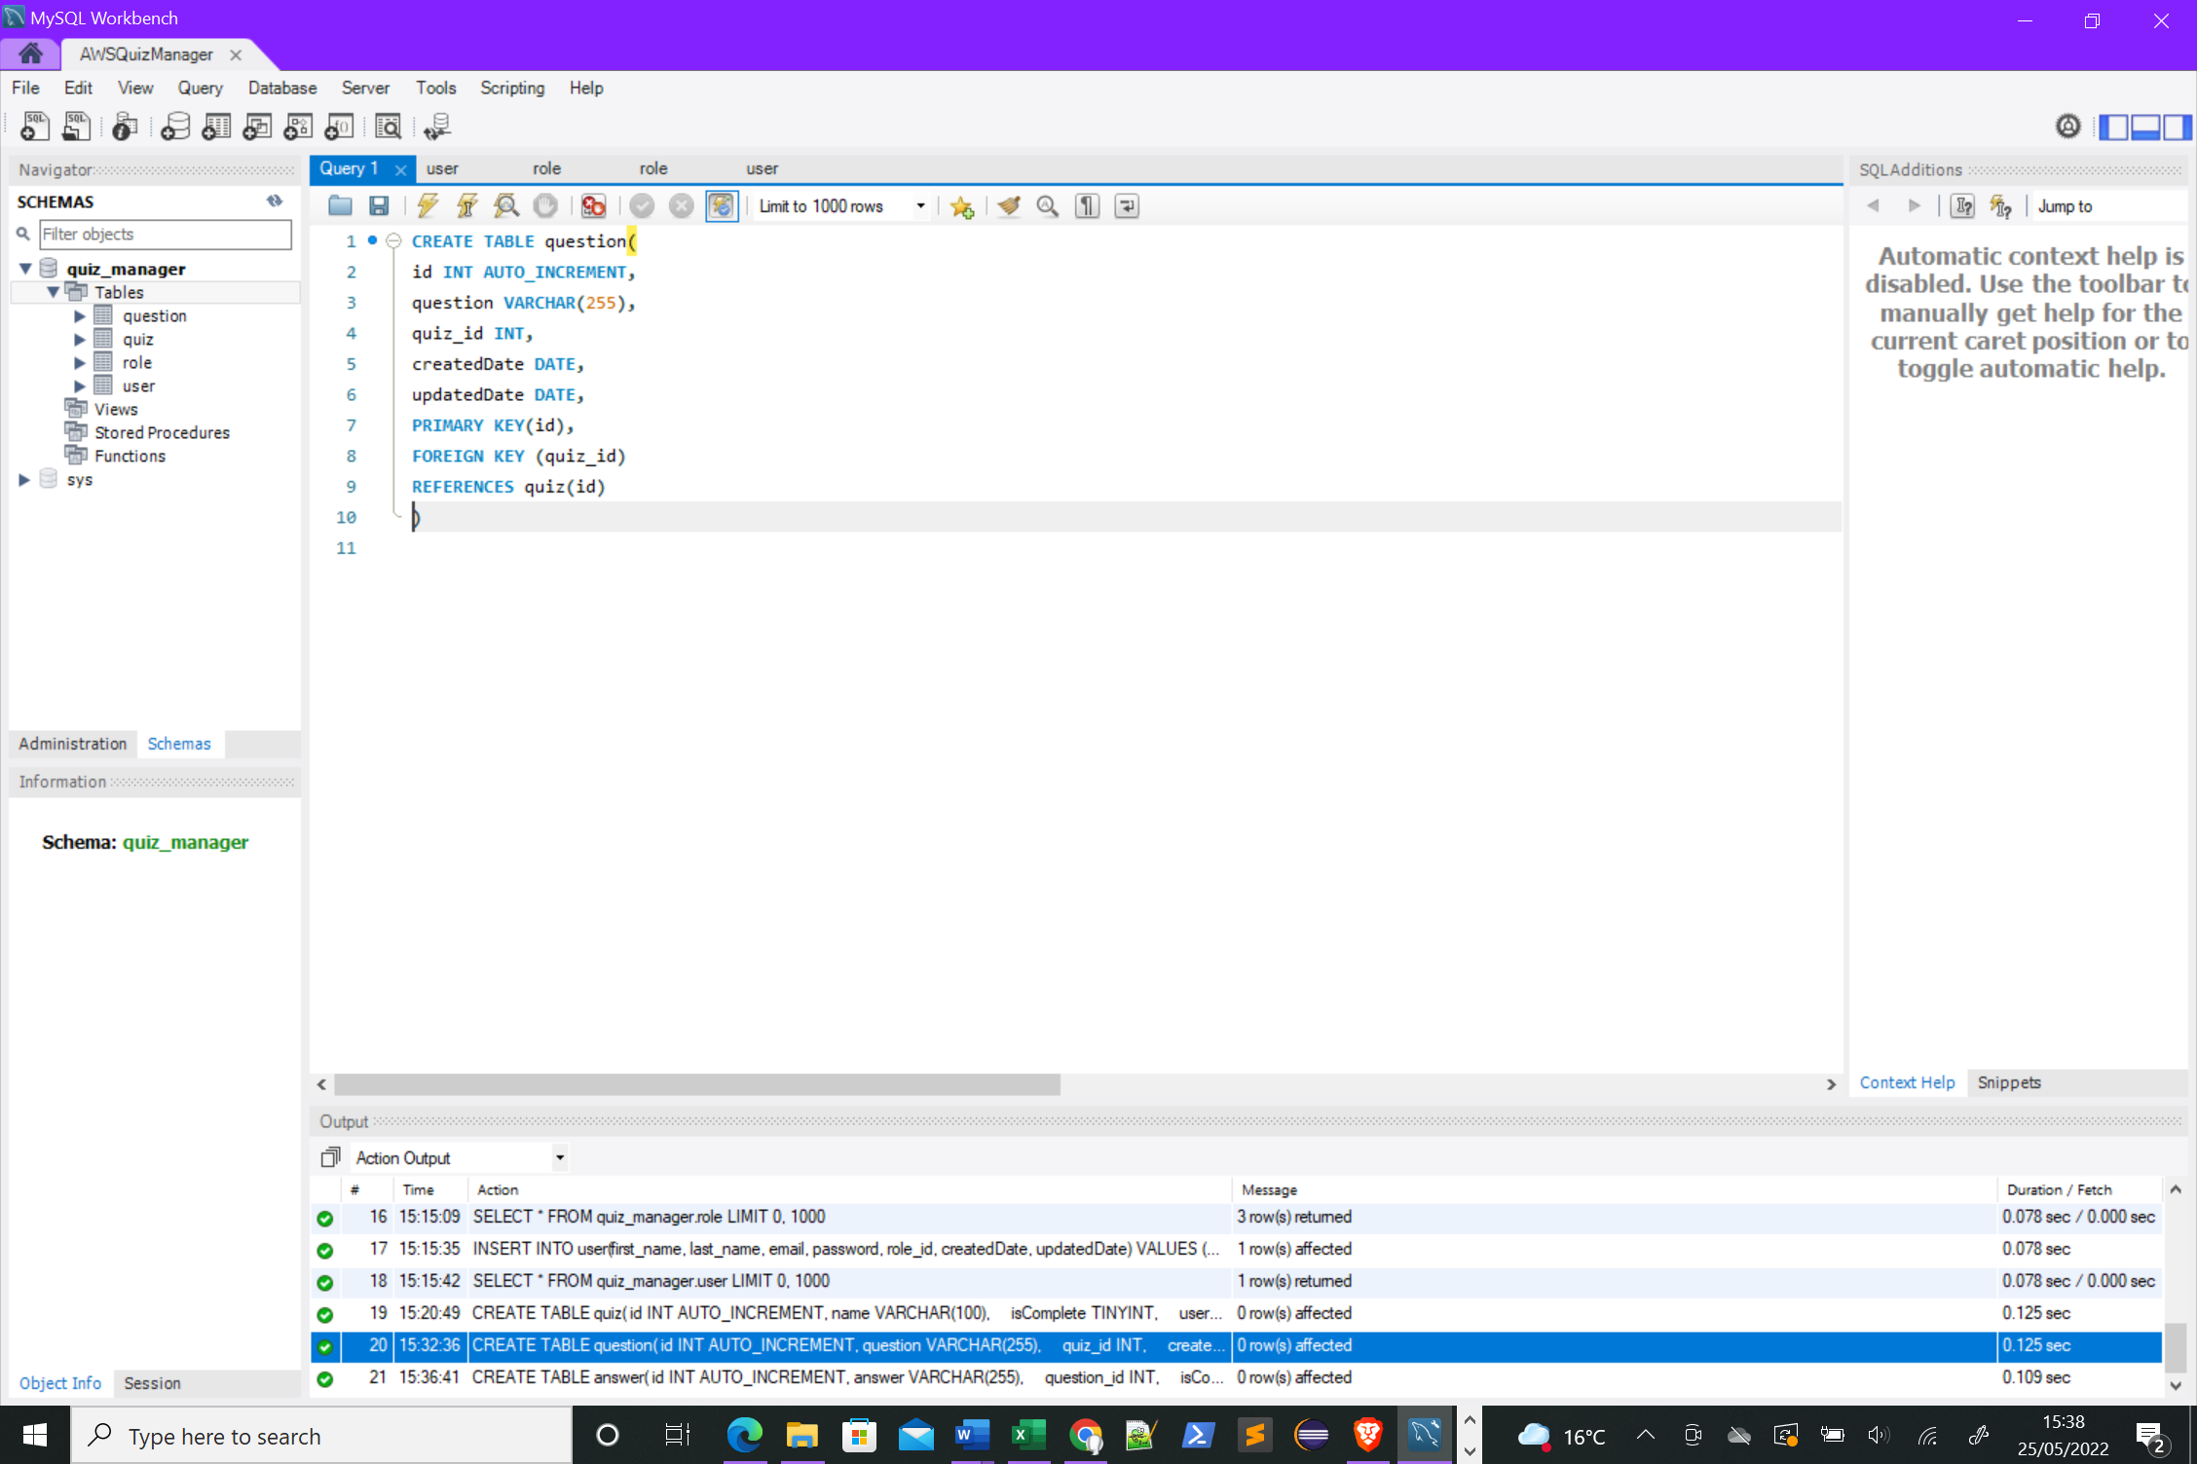

A server now needed to be setup to access the database, I did this in VS code using NodeJS and Express.

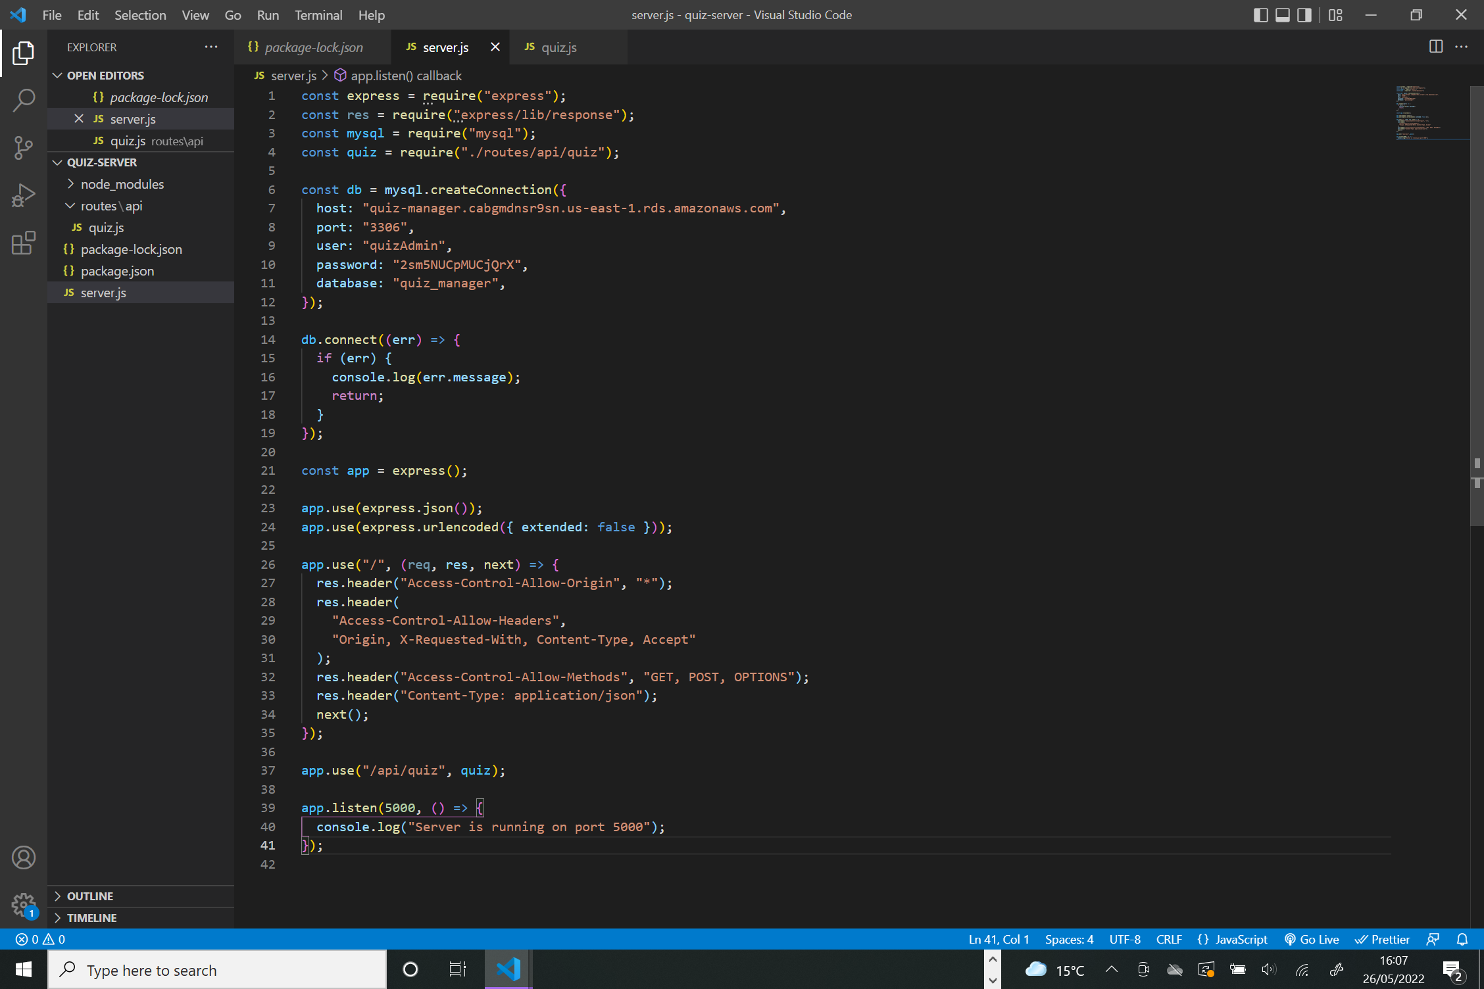

The code in the above screenshot shows that first external packages are imported into the file, express, mysql etc. I then connect to my AWS database. Express middleware is then used to parse requests and headers are set. The express app uses routes and requests another file in line 37. App.listen tells the server to listen for requests.

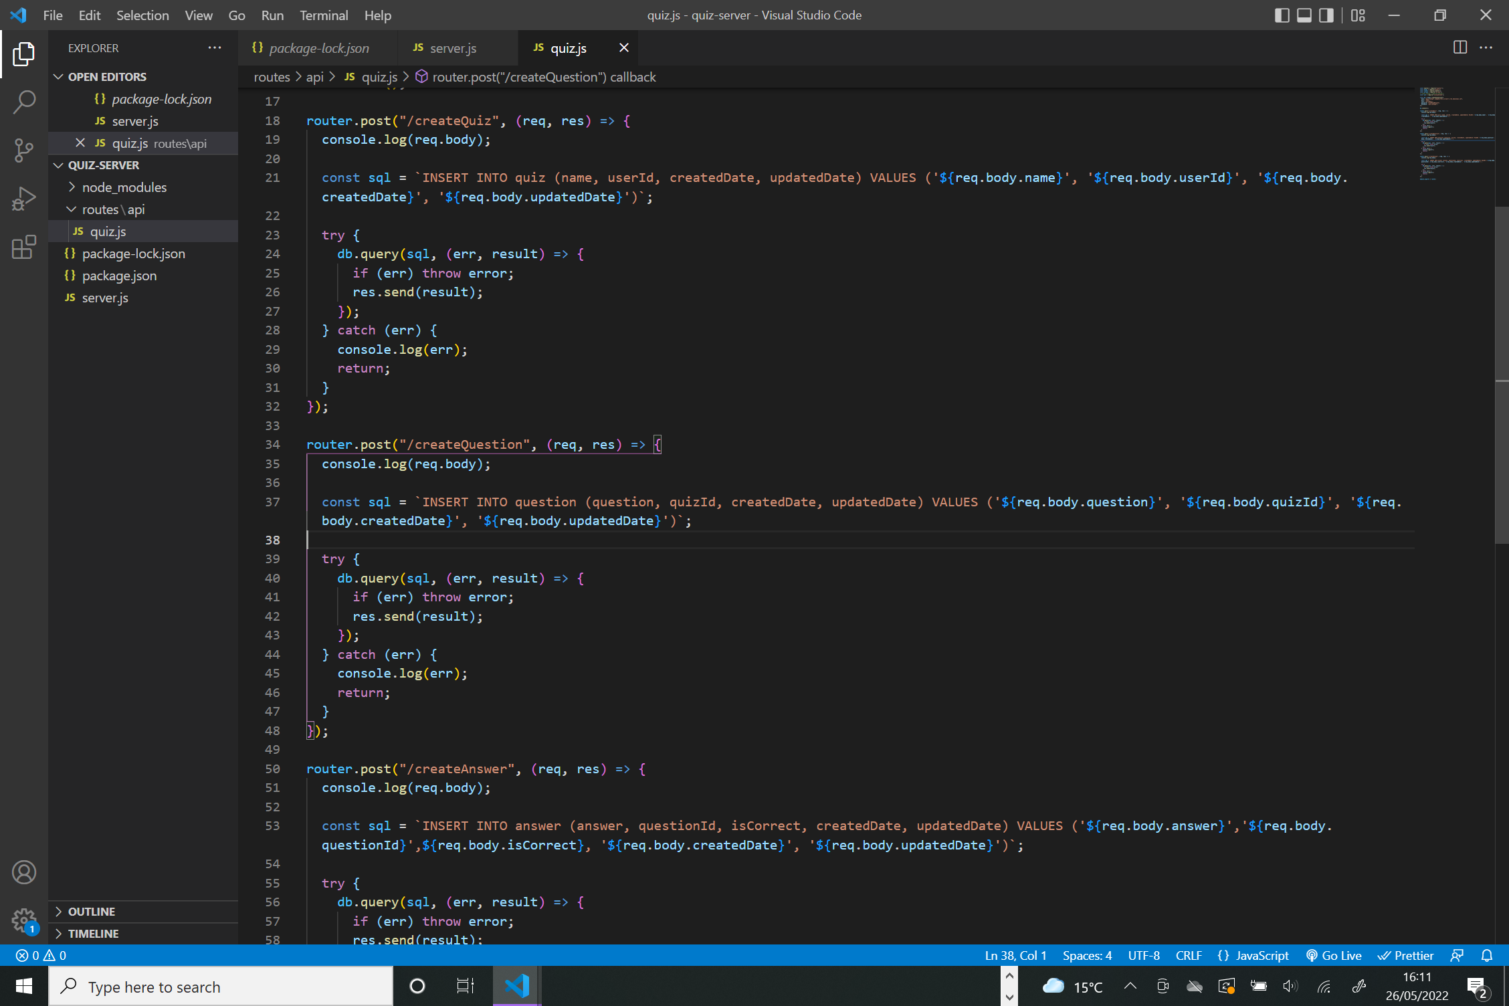

I created another folder called routes/api and created another file within this called quiz.js. This will be route for all api requests relating to creating/editing a quiz.



I wrote a simple post request to the database which will allow a new quiz to be created. First a sql variable is created which will contain the SQL to be executed in the database. The try-catch block then executes this SQL. This will be utilised by the client-side of the application.

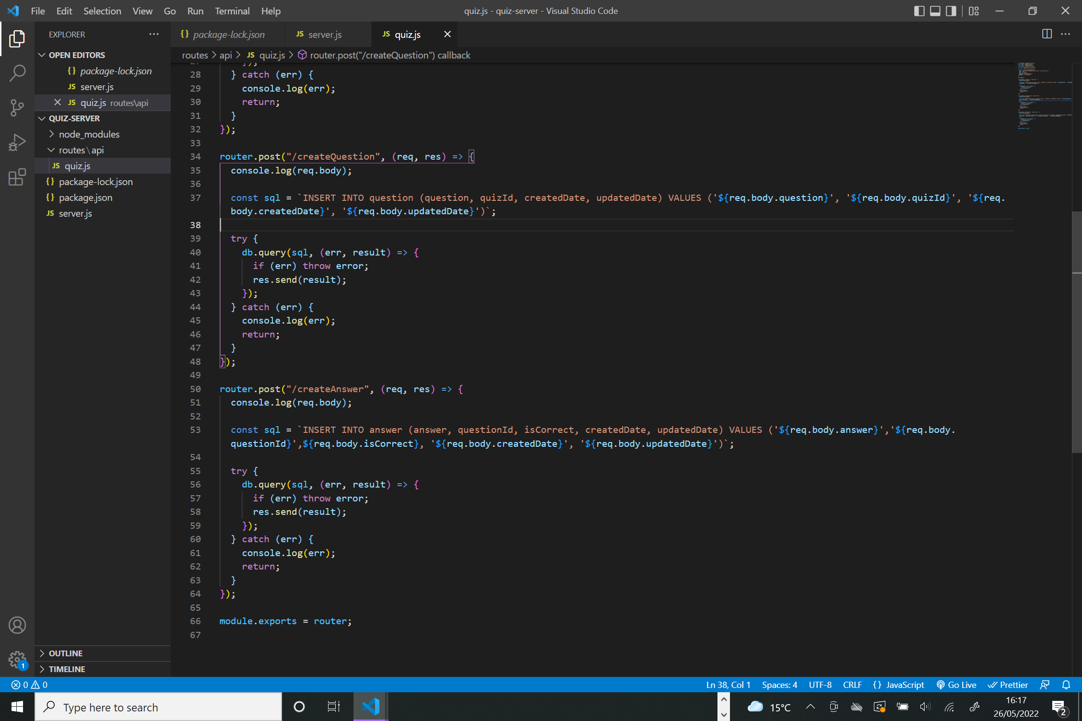

A similar process is followed for the other post requests required for created questions and answers.

# Creating the Front-end

The project was initialised in VS Code using the npx create-react-app command, this generated the folder structure which can be seen on the left hand side.

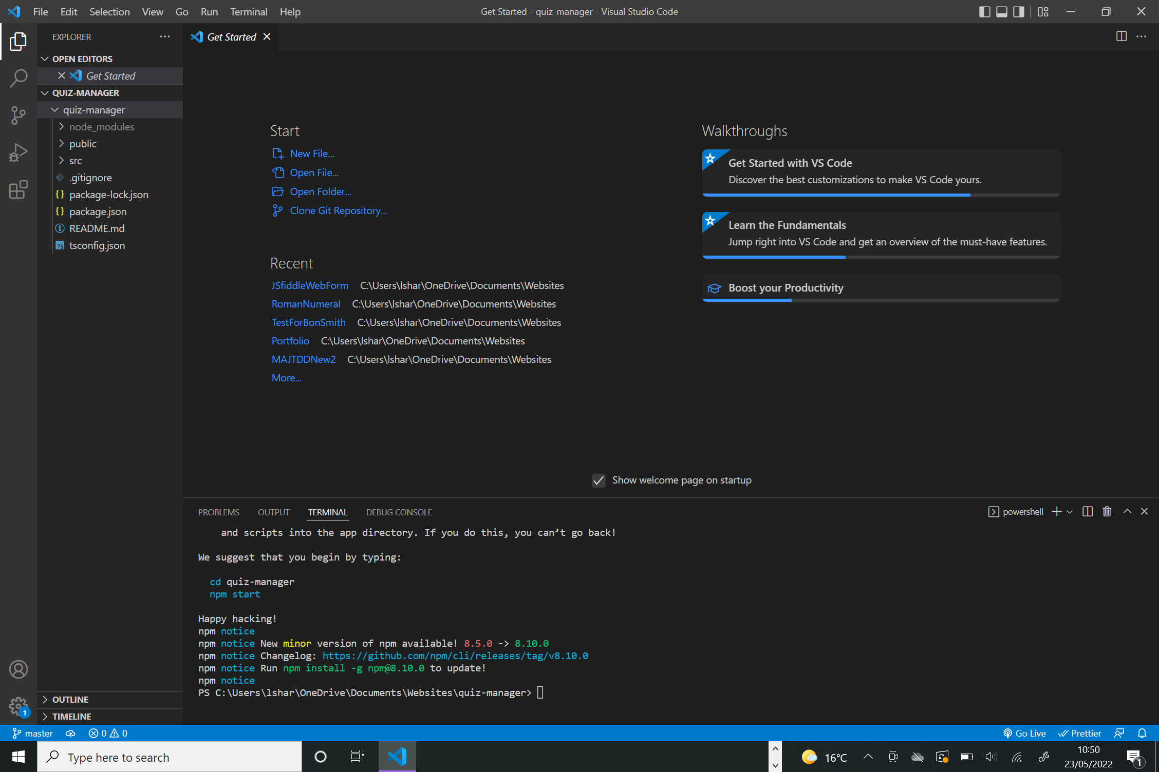

Cypress testing framework was installed.

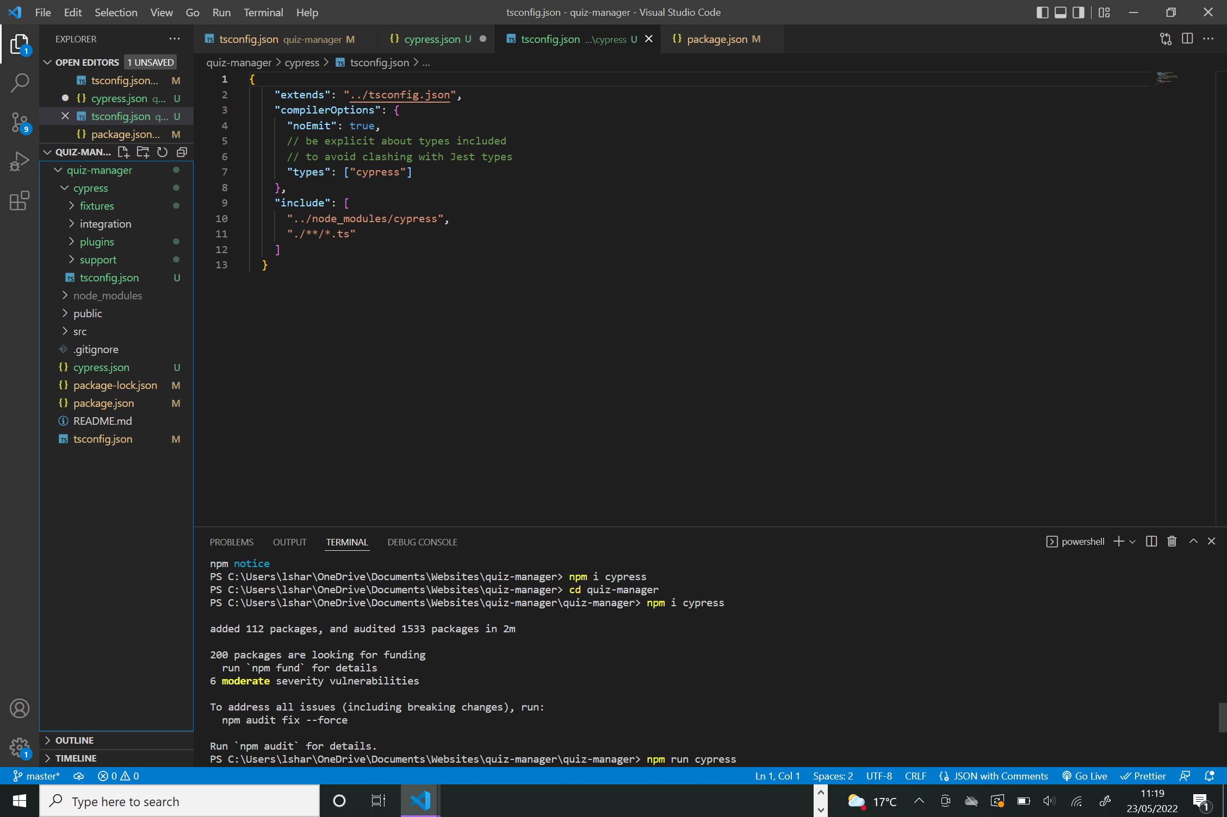

I started by creating a CreateQuiz.tsx component, this would allow you to create a new quiz.

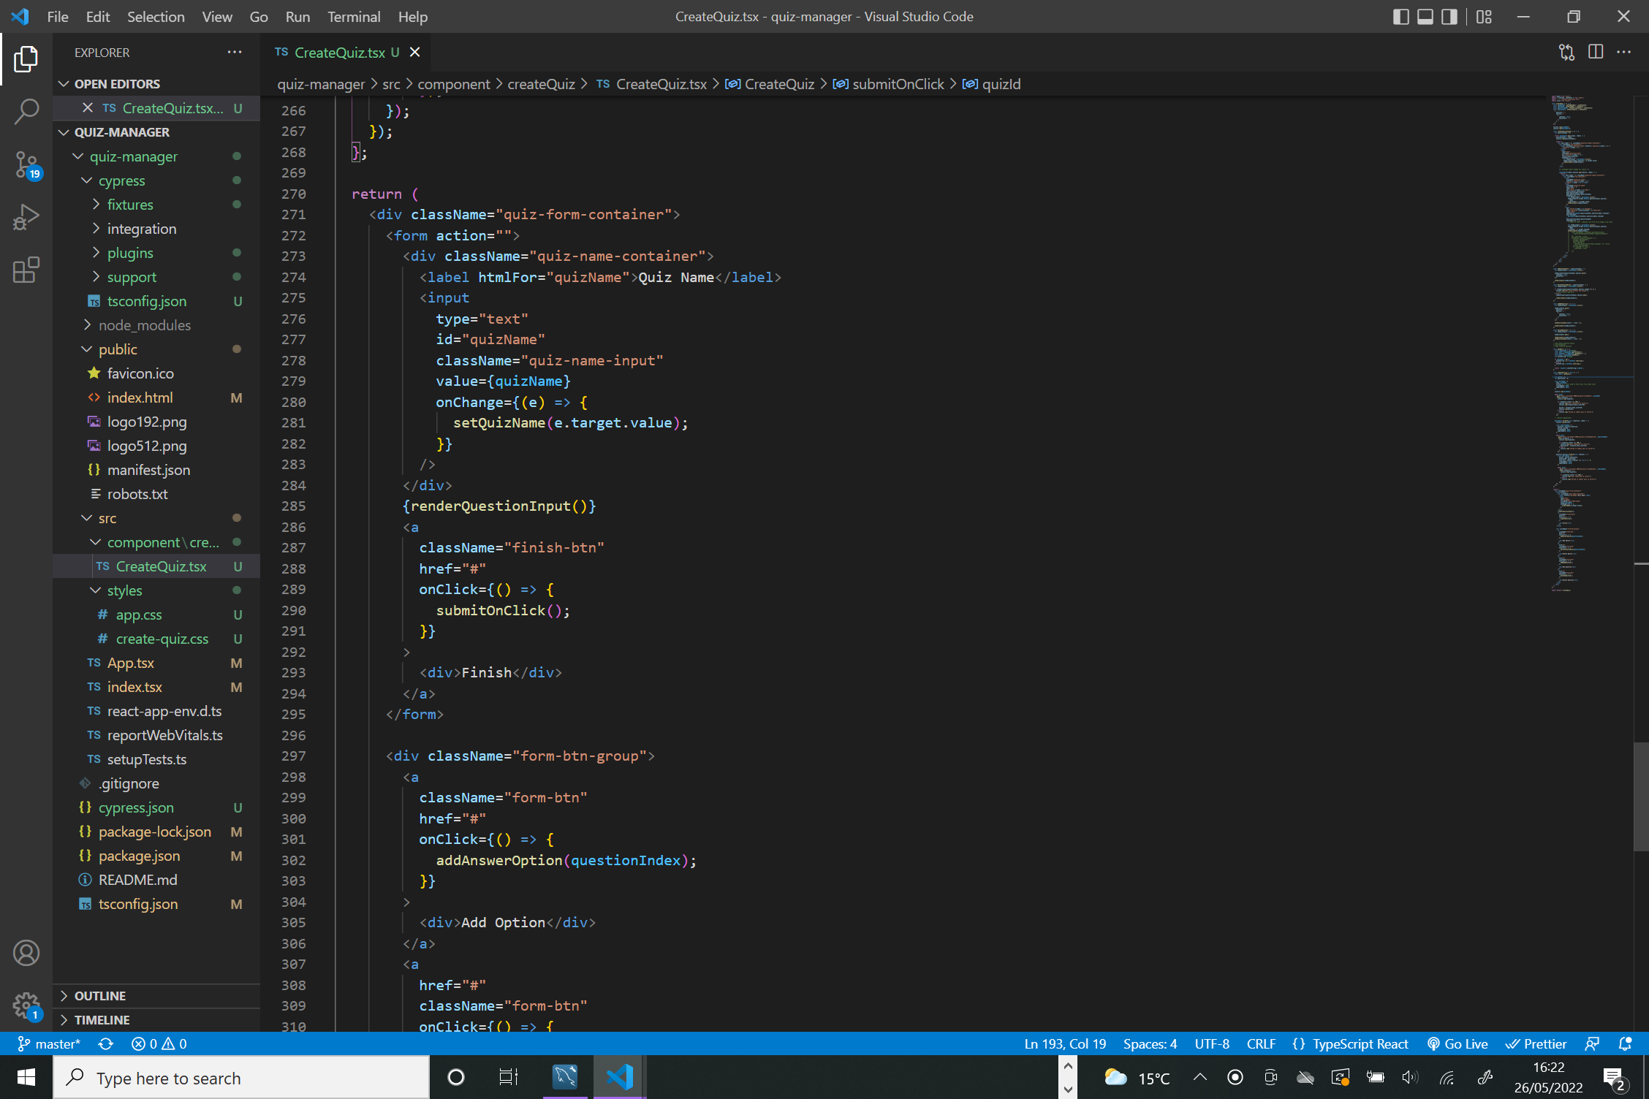

The component will return a dynamically rendering form depending on how many questions and corresponding answers the user desires. This is achieved through a function called renderQuestionInput. This function utilises the components quizInput state composed of an array of objects. The idea behind the function was that it will iterate through the array and render the required number of labels and inputs corresponding to the question.

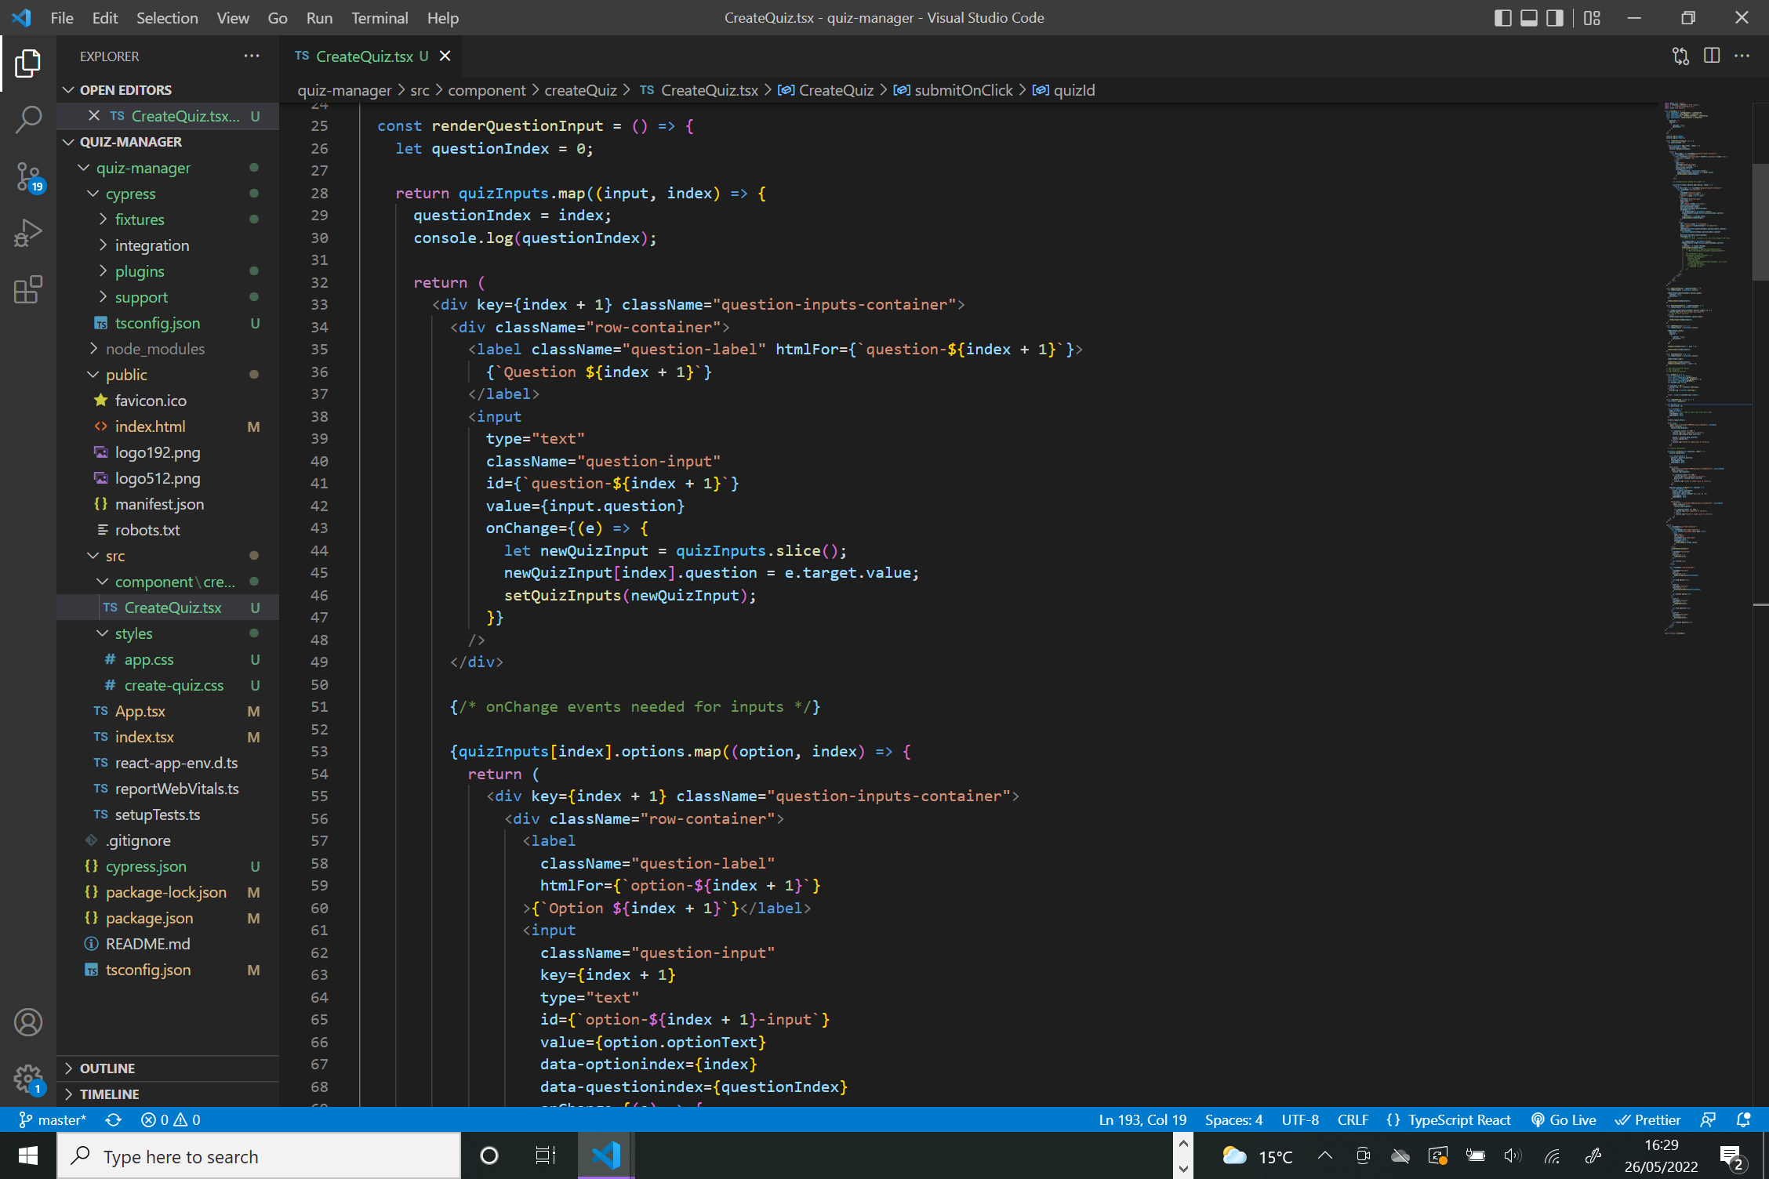

On change events were used on the inputs and would update the quizInputs state when the user changes the value of a question or answer. I assigned classes to the HTML elements in order to style them with CSS.

I wrote the following CSS to style the form.

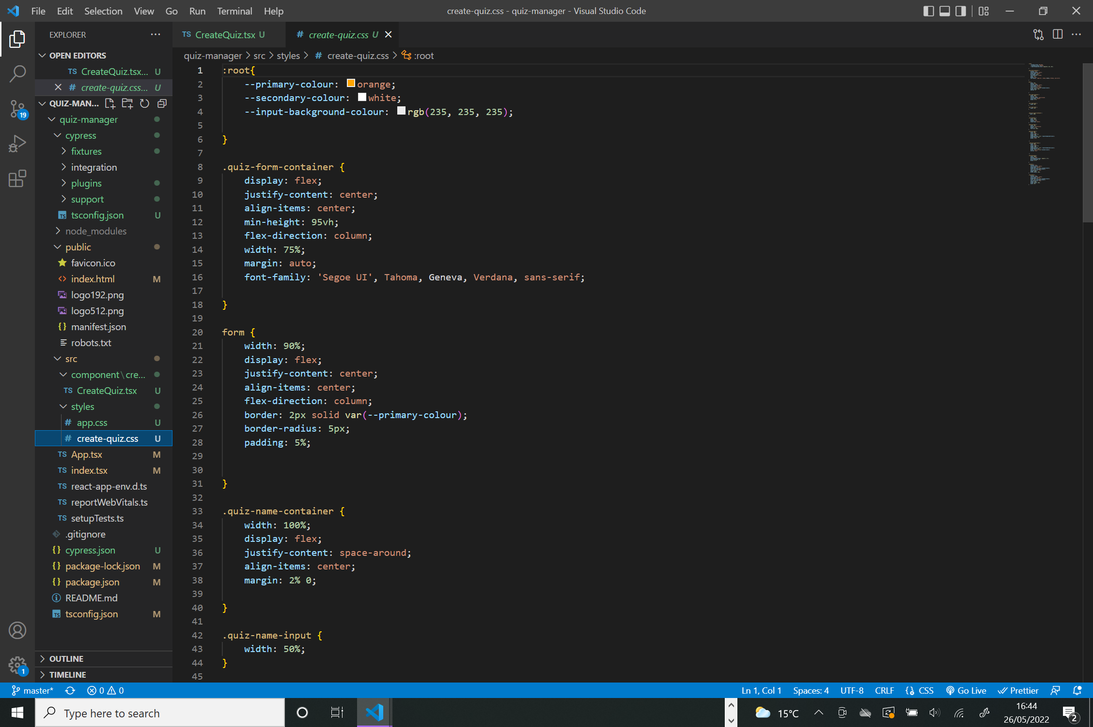

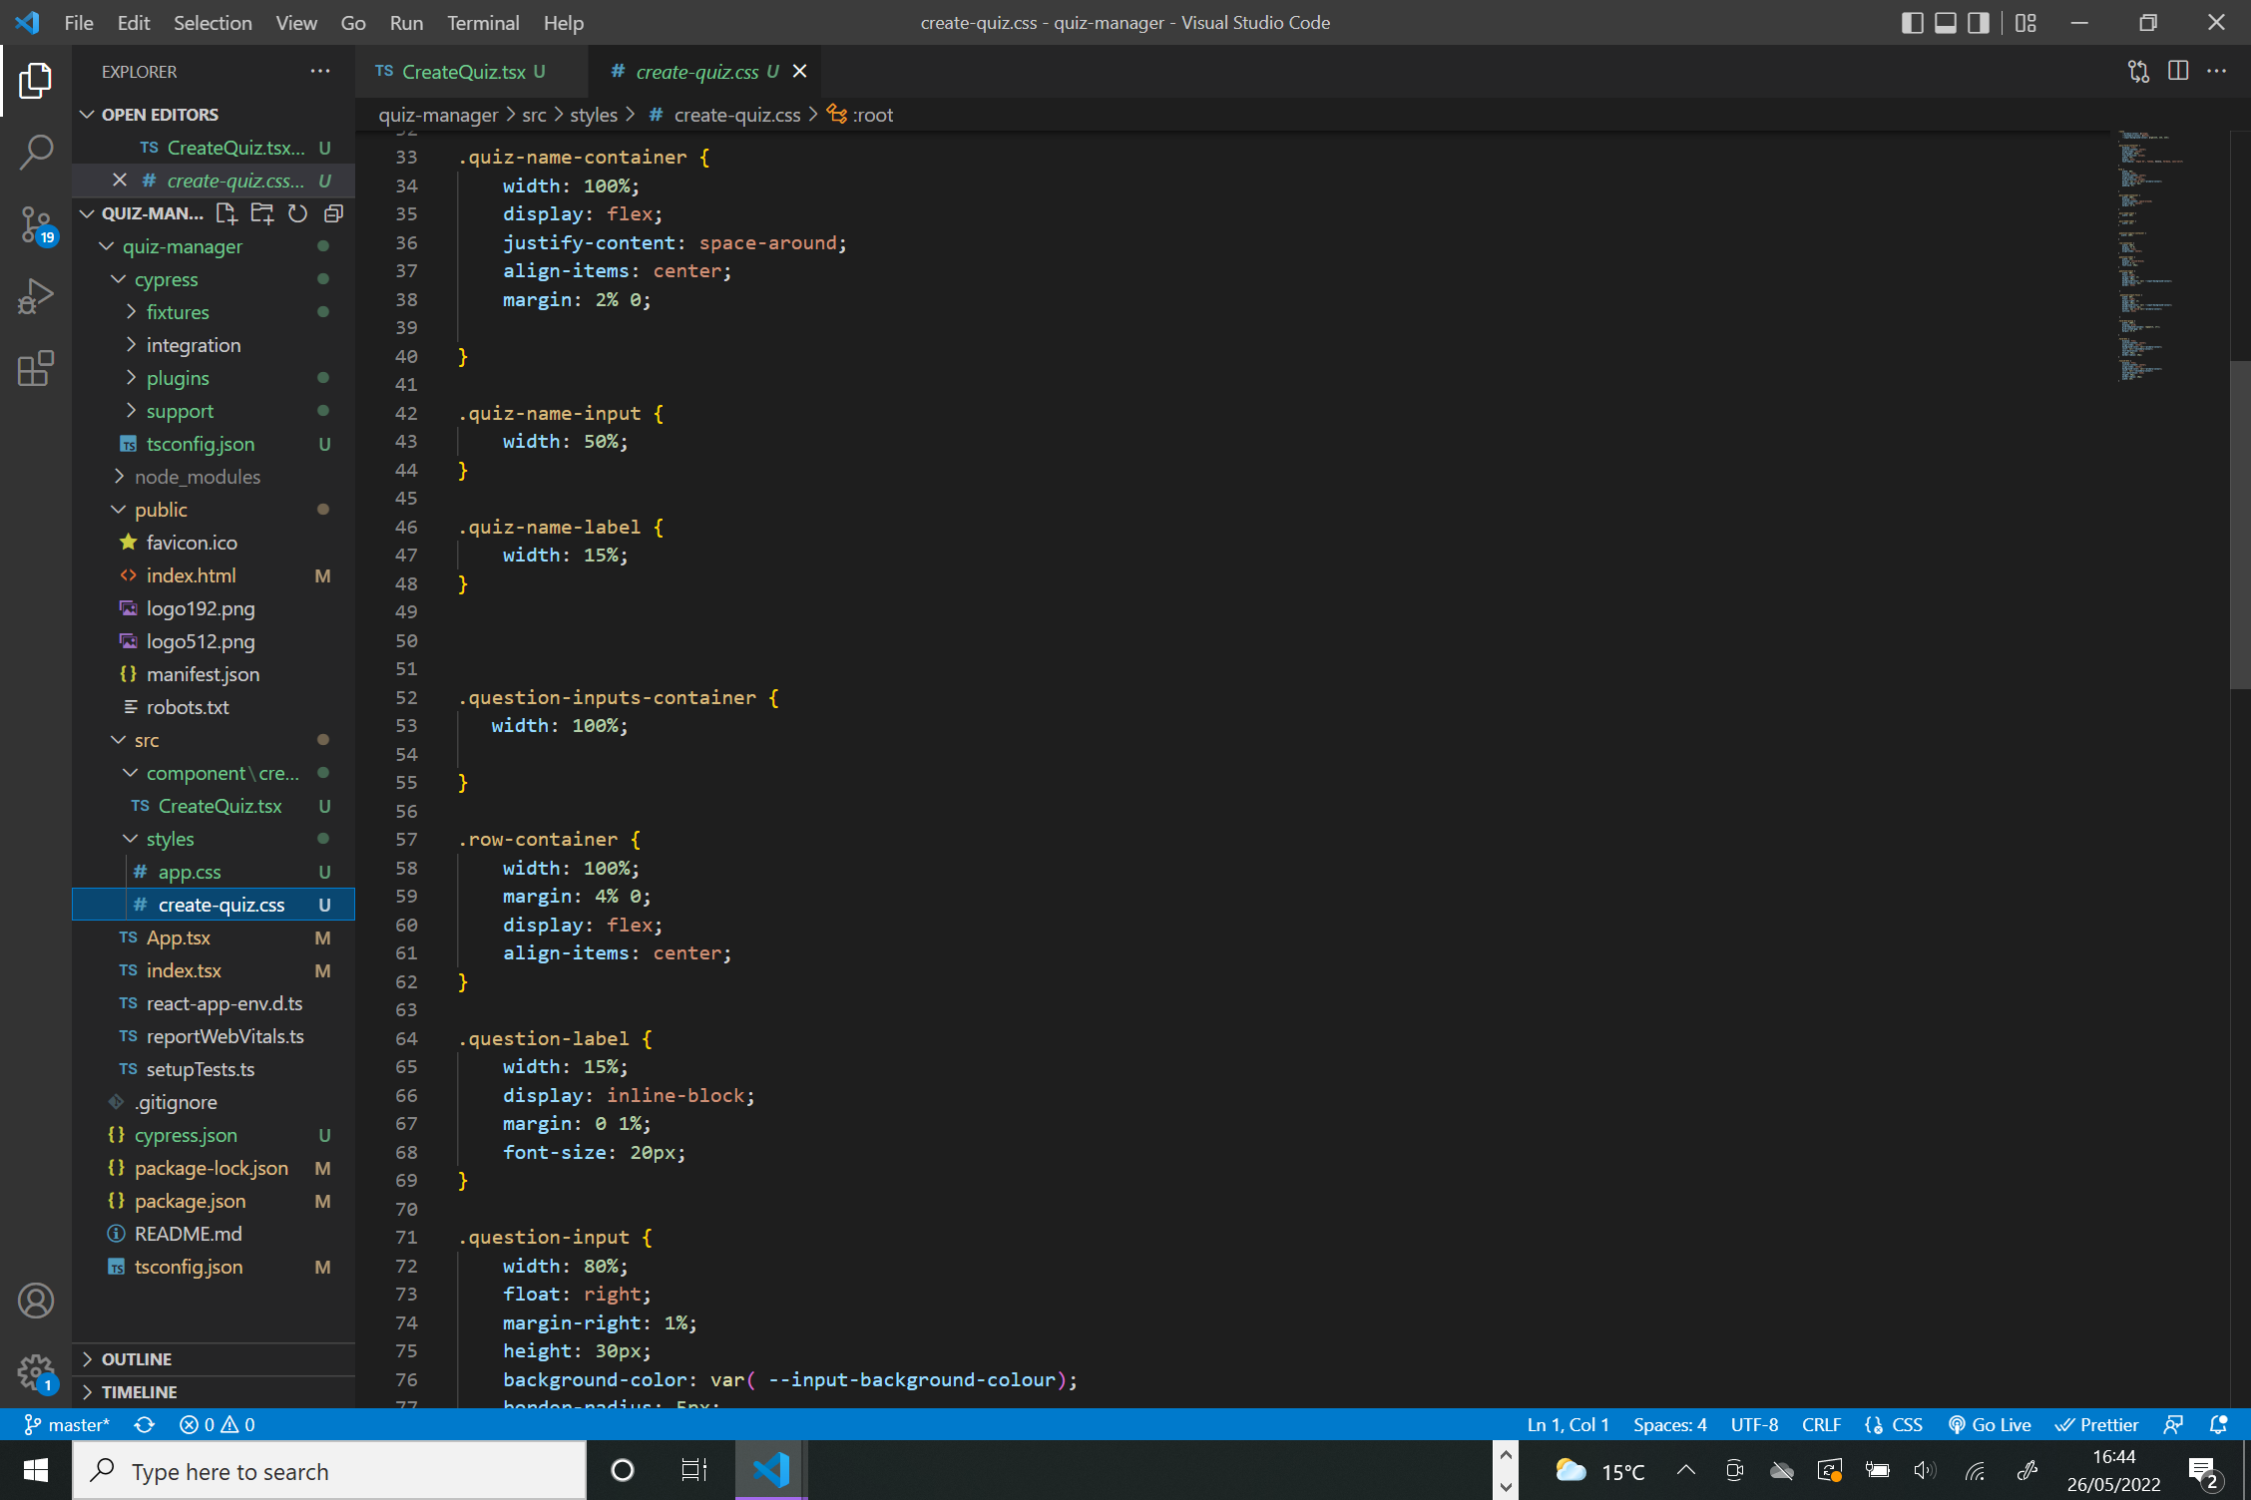

This resulted in the following component rendering in the browser.

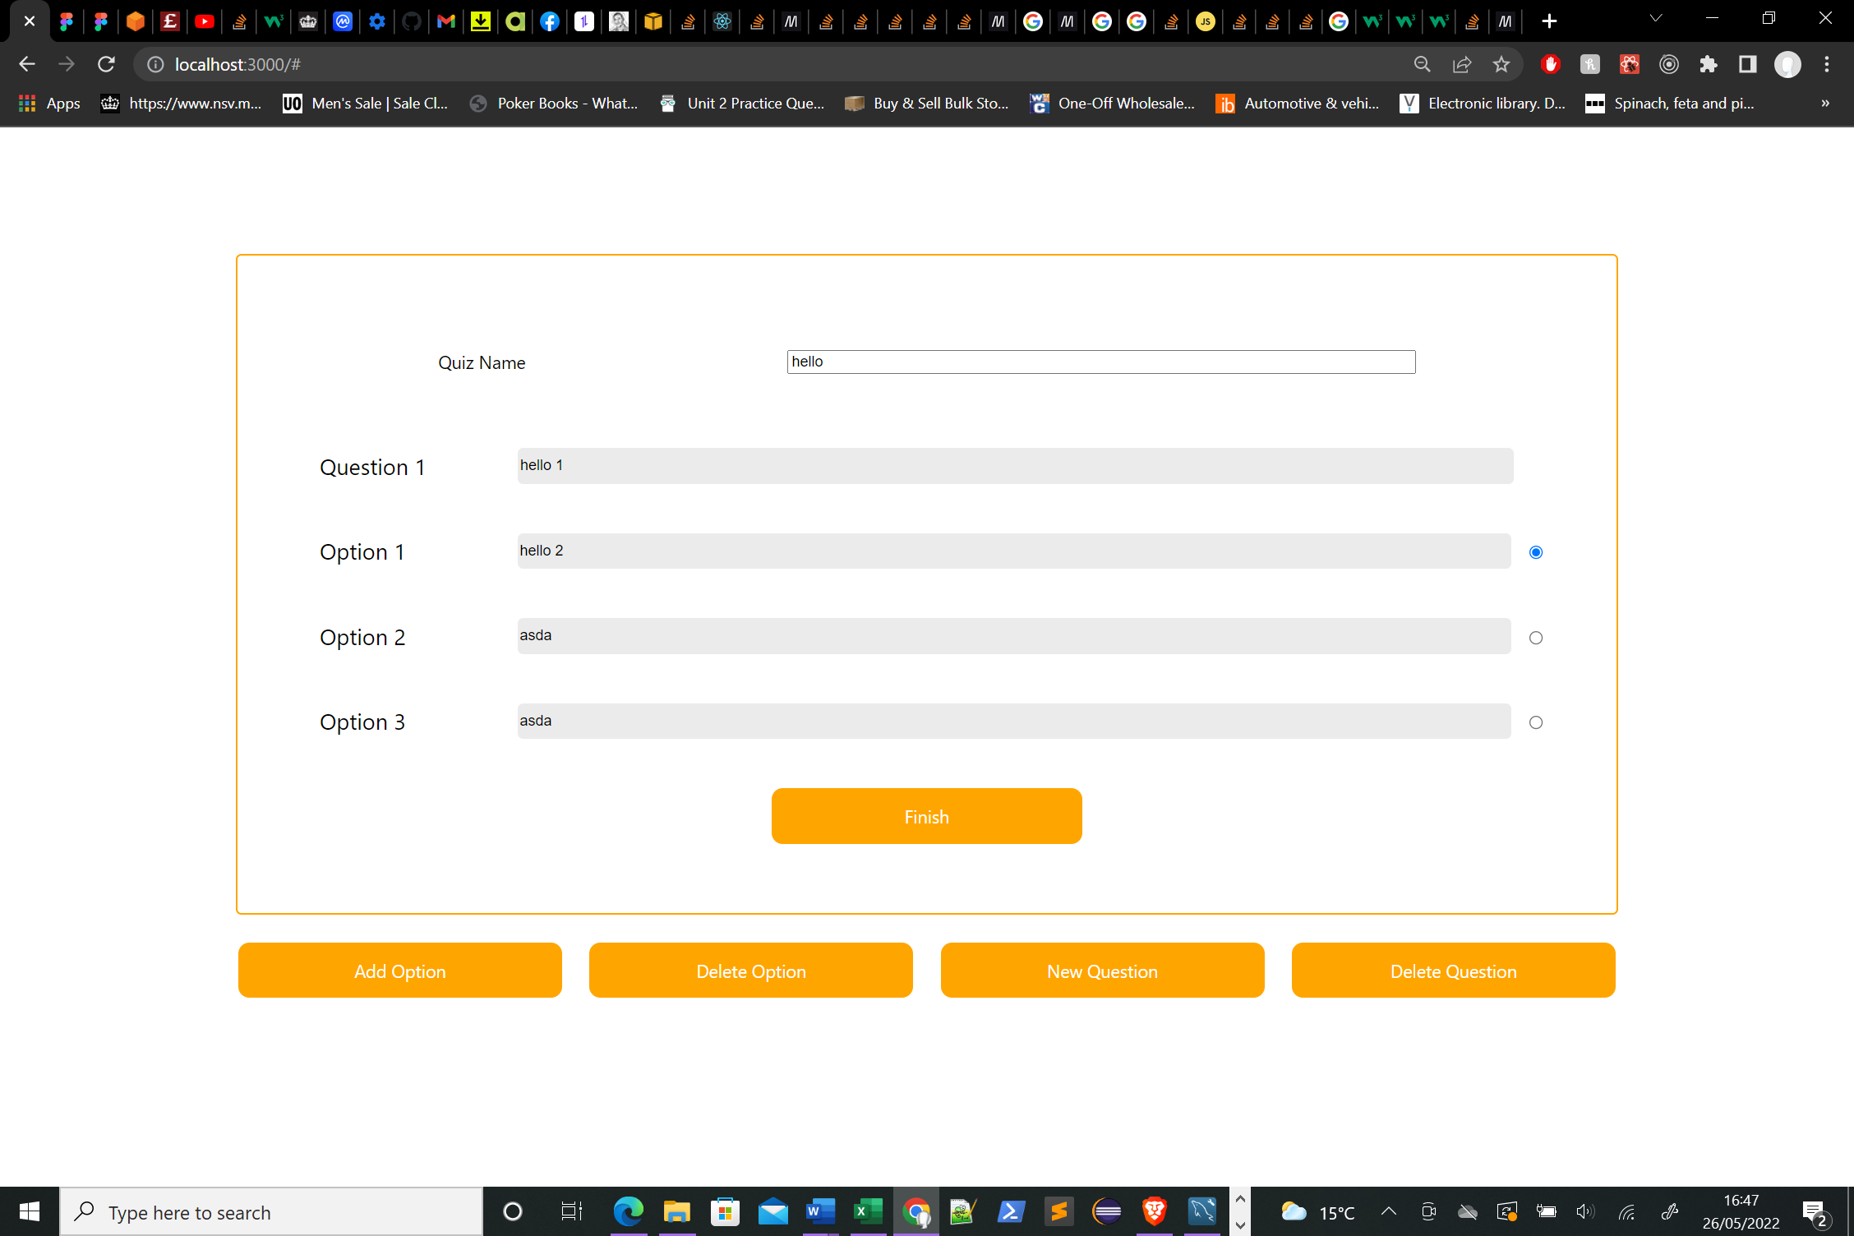

The buttons shown above were used to manipulate the form. I wrote several functions which manipulated the components state to link to these functions.

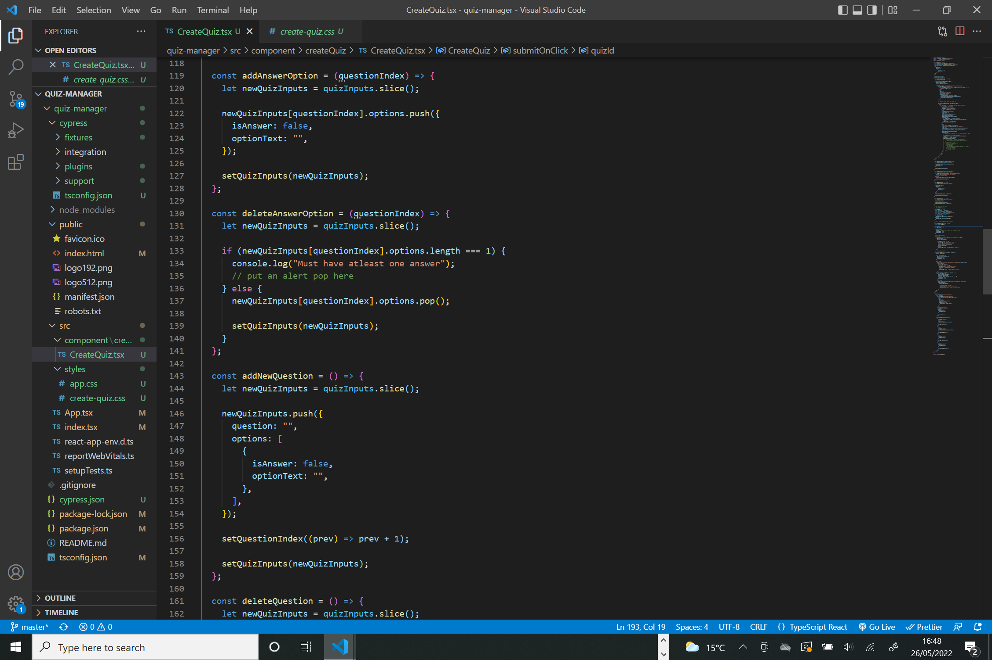

Adding a question would push a new object into the quizInputs array. Similarly deleting would pop an object from the array. A similar mechanism was used add/deleting answer options.

Clicking finish would trigger a series of post requests to the database in the function submitOnClick.

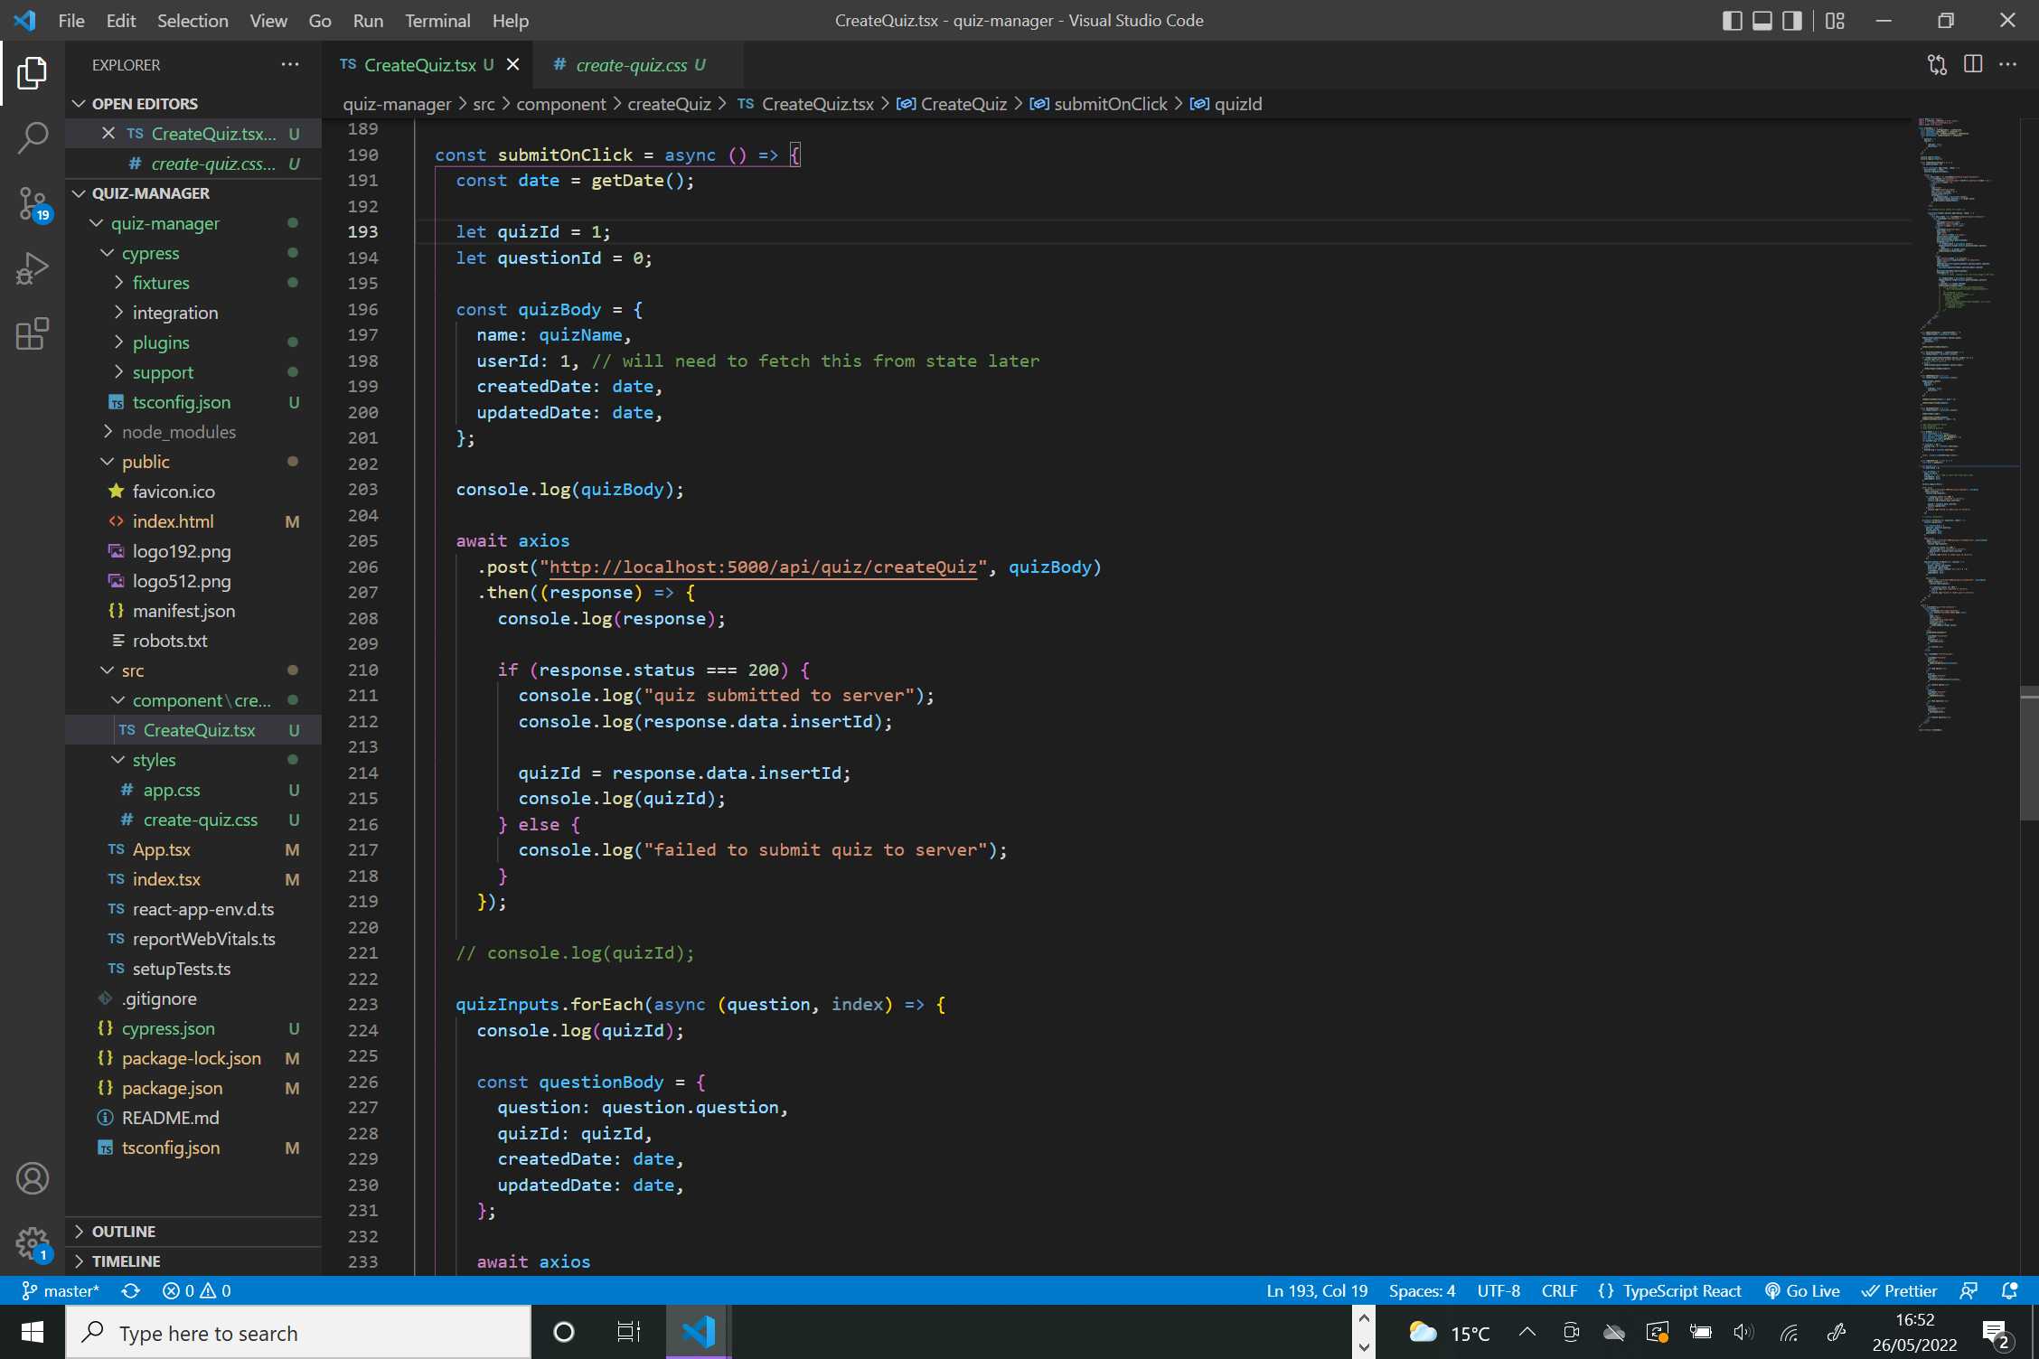

During submitOnClick, the function iterates through the quizInputs state. The function creates a body to be sent with the post and then axios is used to send the request.

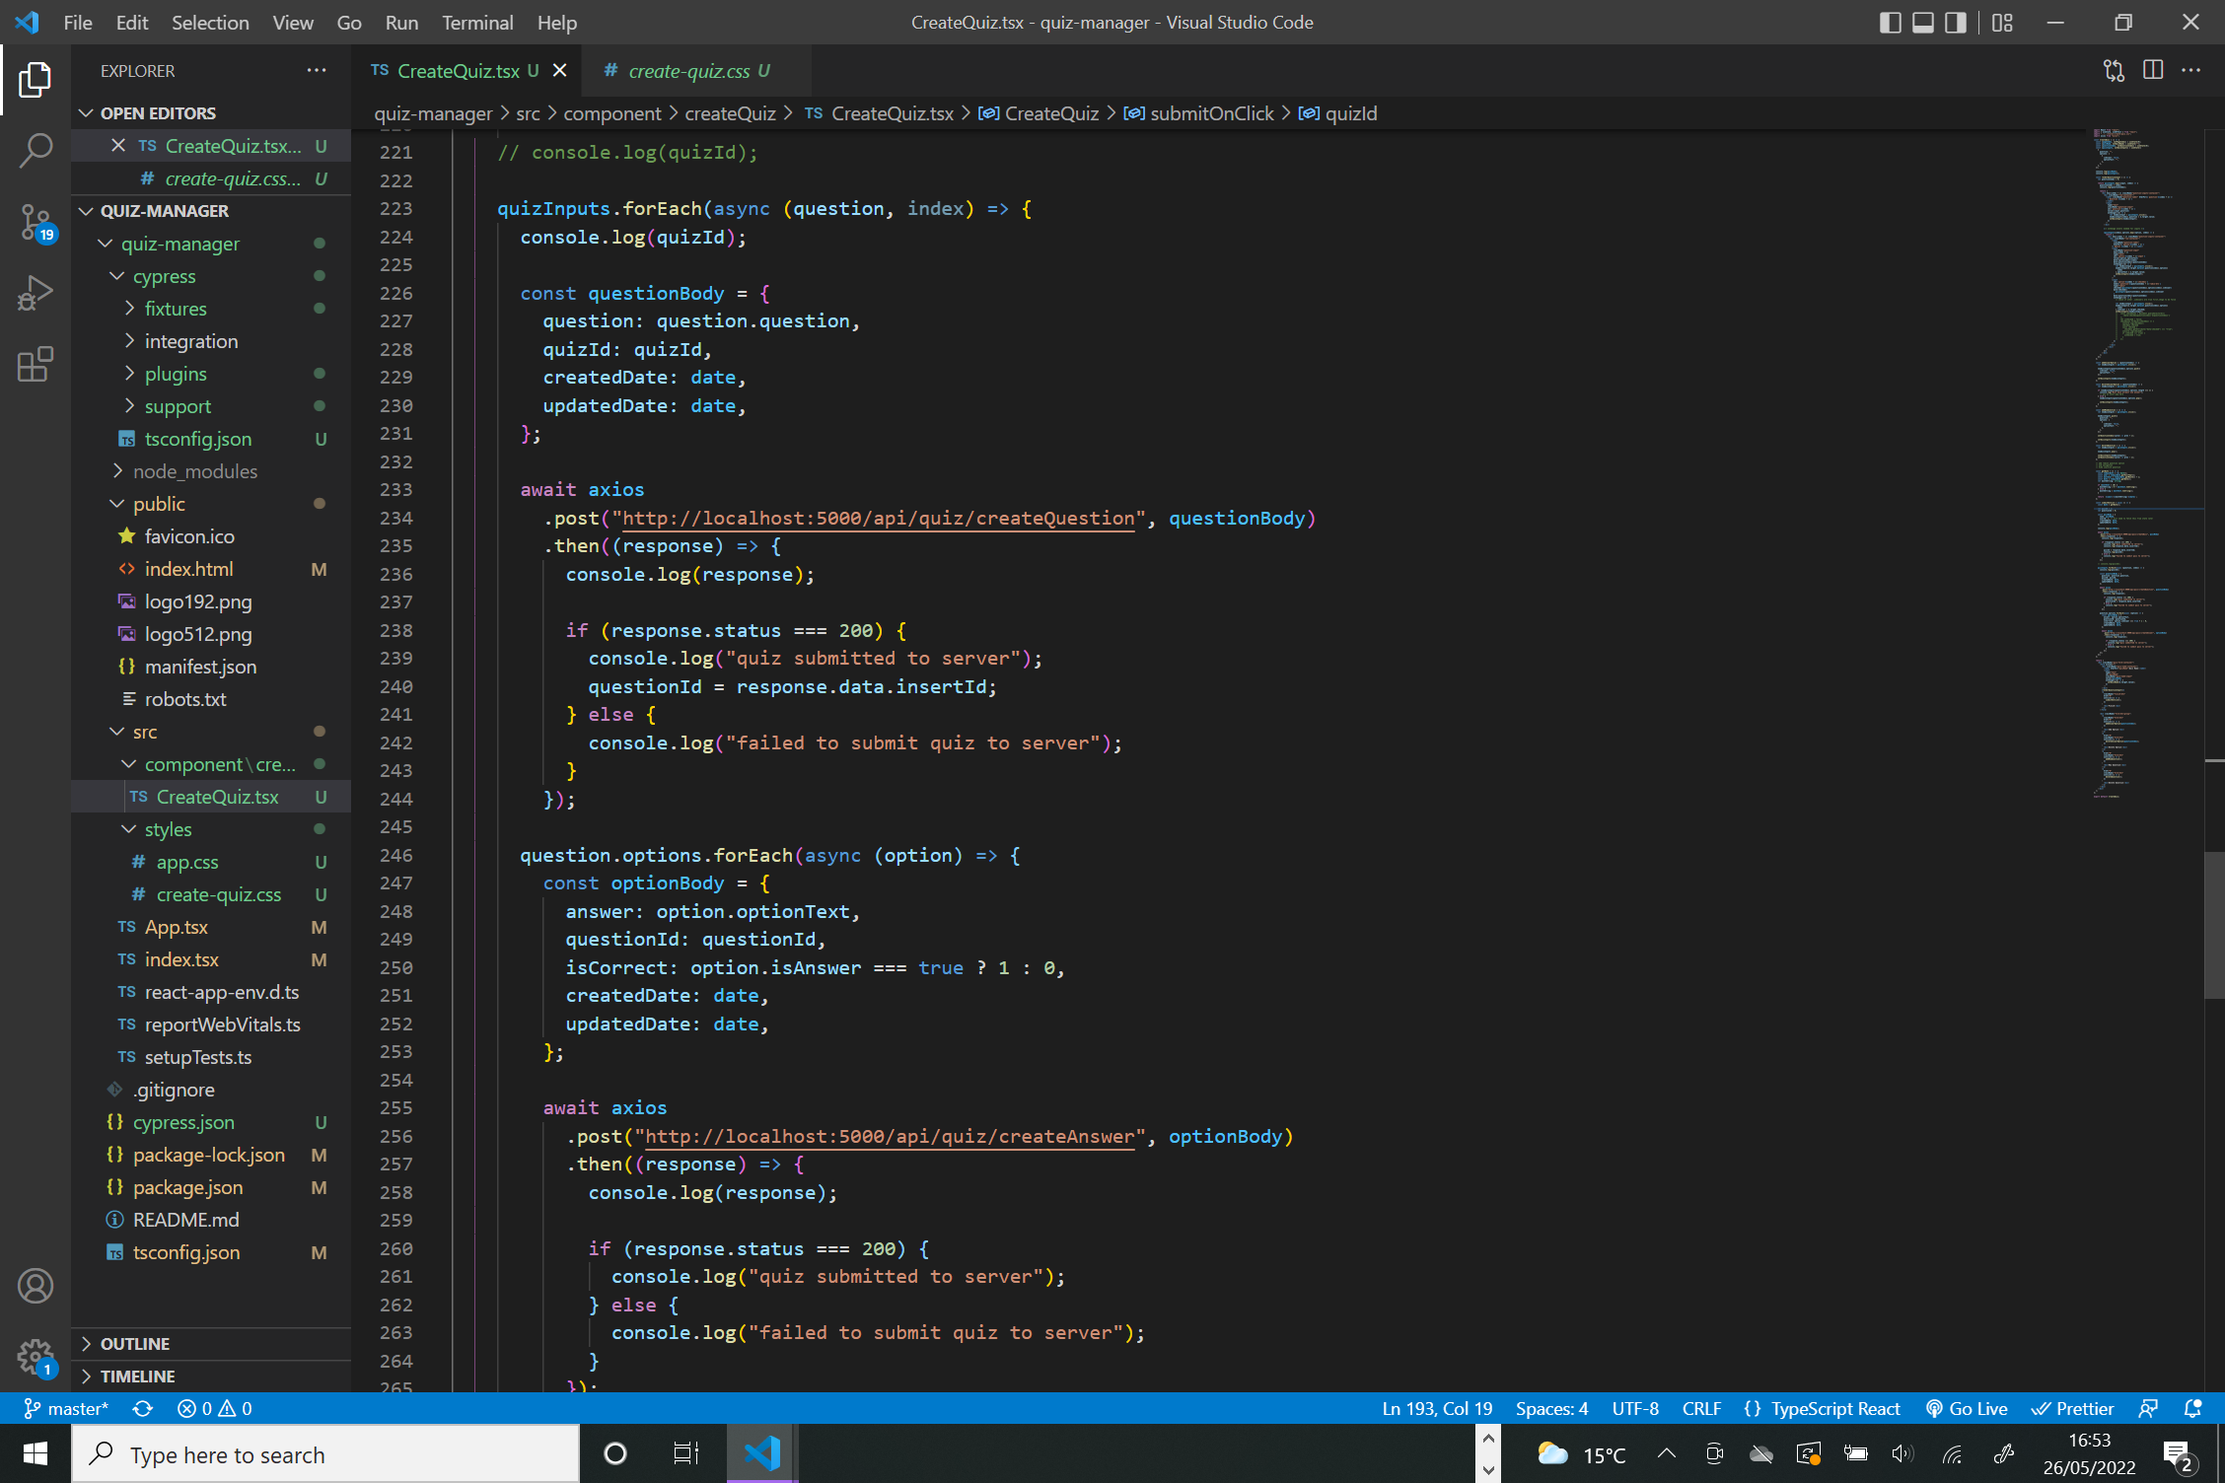

# Conclusion

I successfully created a component for creating a new quiz as well as functional backend but unfortuantely I ran out of time to complete all the features that were required for the project. I would have used jsonwebtokens to implement a login screen. A CORS issue with GET requests meant I was unable to create functioning versions of the quiz view.